**Design Document for:**

# **Open Sea 1520**

**Explore, Trade, and Adventure around the Renaissance all the way to The New World.**

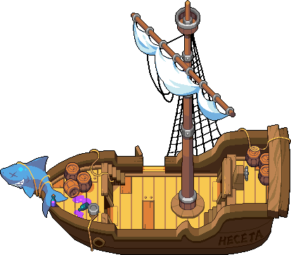

Written by Vibha Alangar, August Dailey, Tyler Frantom, Aaron Michael, and Jenner Wile

Tuesday, October 17, 2017

Table of Contents

**Open Sea 1520** **0**

**Game Overview** **6**

Game Description 6

Controlling the Hero 6

What makes this game unique? 8

**Feature Set** **9**

General Features 9

Gameplay 9

**The Game World** **10**

Overview 10

Travel 27

Objects 28

Weather 28

Day and Night 28

Time 28

Camera 30

Overview 30

Game Engine 30

Overview 31

Game World Mechanics 31

Water 31

Collision Detection 32

Lighting Models 32

Overview 32

Lighting Model Detail - Indoor 32

Lighting Model Detail - Outdoor Daytime 33

Lighting Model Detail - Outside Nighttime 33

Lighting Model Detail - Storm Nighttime 34

**Narrative Story** **35**

**The World Layout** **36**

Overview 36

**Game Characters** **36**

Overview 36

Hero Customization 37

Defeating the Pirates 37

**User Interface** **37**

Overview 37

Menus 38

Game World 45

**Combat** **49**

Overview 49

Ship Combat 50

Pillaging 50

**Musical Scores and Sound Effects** **50**

Overview 50

Sound Effects 50

Main Scores 52

Character Themes 52

Musical Elements 52

**Single-Player Game** **52**

Overview 52

Sailing 52

Storage 53

Fishing 53

Port Cities 53

Trade 53

Shopkeepers 53

Shipbuilders 53

Pricing 54

Victory Conditions 54

Post-Story 54

Hours of Gameplay 54

**Quests** **55**

Overview 55

Quest Journal 55

Main Story Quests 55

Port specific quests 56

Side Quests 57

Upgrade Quests 58

Other 59

**Extra Miscellaneous Stuff** **61**

Dropped ideas (implement later if feasible): 61

**Character Appendix** **62**

Captain Red Jacket 63

First Mate (Jacob) 65

Mother/Father 66

Love Interest (Angelo/Angela) 67

Overview 67

Ghost 68

The Kraken 69

Barkeepers 70

Merchants (Michael) 71

Shopkeepers 73

Shipbuilders 74

Port Authorities 75

Village Idiot 76

Sailors/Crew 77

Pirate Crew 78

Town Guides 79

Marco 80

**Goods Appendix** **81**

**Ship Upgrades Appendix** **82**

**Map** **84**

**Story Appendix** **85**

# 

# 

# **Game Overview**

## **Game Description**

Open Sea 1520, a game set in the Mediterranean in the 1520’s, was inspired by the game Stardew Valley. Although that game was great, there was an obvious lack of boats. Open Sea 1520 allows the player to experience the unique opportunity of obtaining, upgrading, and sailing their own personal ship through the Mediterranean sea, while also being able to make personal connections with other NPC’s.

Throughout the course of this game the player will encounter friends and enemies, old and new, and eventually the player might hopefully make it to the Americas. Before the player can take on their final expedition to the Americas, they must complete quests, gather supplies, and recruit crew members to build up the strength to overcome the hardships of sea, whether it be pirates or starvation.

### **Controlling the Hero**

Control the Hero on land

* Controls

|  |  |
| --- | --- |
| **Key** | **Action** |
| W | Move up |
| A | Move left |
| S | Move down |
| D | Move right |
| Left Click / E | Interaction |
| I | Inventory |
| Escape | Menu |
| Left Shift | Increase walking speed (run) |

Control the Hero’s ship at sea

* Controls (non-combat)

|  |  |
| --- | --- |
| **Key** | **Action** |
| W | Increase forward velocity |
| A | Turn ship left |
| S | Increase backward velocity |
| D | Turn ship right |
| Left Click / E | Interaction |
| I | Inventory |
| Escape | Menu |

* Controls (combat)

|  |  |
| --- | --- |
| **Key** | **Action** |
| W | Increase forward velocity |
| A | Turn ship left |
| S | Increase backward velocity |
| D | Turn ship right |
| Left Click / E | Interaction |
| I | Inventory |
| Escape | Menu |
| Numbers (0-9) | Select Weapon/Launch Weapon |

Control the Hero walking on their ship/pillaging other ships

* Controls (Pillaging)

|  |  |
| --- | --- |
| **Key** | **Action** |
| W | Move up |
| A | Move left |
| S | Move down |
| D | Move right |
| Left Click / E | Interaction |
| I | Inventory |
| Escape | Menu |
| Left Shift | Increase walking speed (run) |

**Main Focus**

The main focus of this game is to get to the find Captain Red Jacket to eventually avenge the death of the Hero’s family. However, there is also a will to explore the Mediterranean and eventually the Americas driven by the legacy of the Hero’s father.

### **What makes this game unique?**

Open Sea 1520 combines the aspects of many popular games in order to create the ideal game. It utilizes Stardew Valley’s gorgeous pixel art style, Pokemon’s stellar camera angle,and Sunless Sea’s magnificent sailing user interface, combined with questing, pirates, boats, and a fun yet gripping story to create plethora of possibilities for the player to explore.

# **Feature Set**

## **General Features**

* The ability to control your own ship and navigate through the Mediterranean
* Character customization
* Bird’s eye view camera style
* NPC relationships
* Main questline and side quests to guide the journey
* Upgrade your ship by collecting and trading for the necessary items
* Customize your manor once your reach the Americas
* Complete quests in order to gain gold and resources
* Pixel sprite designs

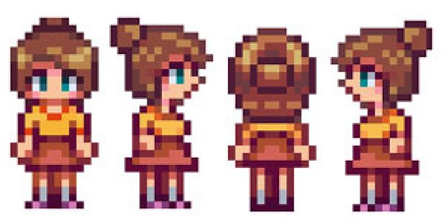

*Image: http://stardewvalleymods.net/brunette-penny-mod/*

## **Gameplay**

* Explore 11 port cities connected by sea routes
* Trade and Interact with other NPC characters
* Build up enough gold to eventually be able to afford the supplies and upgrades to reach the Americas
* Track down Captain Red Jacket to avenge the family of the hero and citizens of Malta
* Find friendship with other NPC’s as you attempt to recruit them for your crew
* Develop a bond with your first mate and quartermaster in order to successfully develop a ship and crew to one day be better than your father’s.
* Build trust and compassion with a love interest
* Cast out your ship’s net in order to gain extra supply of food while you roam around the port cities
* Fight other ships and raid them for resources

# **The Game World**

## **Overview**

Open Sea 1520 is set on Earth in the year 1520. Most of the action takes place in and around the port cities in the Mediterranean sea. The game is designed to hold as true to real life as possible, and the major point of the game is to explore. The details put into the game world lend itself easily to the casual adventure genre of the game. Characters are also realistic in nature, in that they need food and water to survive, and they have individual motivations and emotions.

**Connection to History**

An interesting feature of this game is its connection to history. Special care was taken in the design of this game so that it would stick as true to history as possible. All the port cities are real places that existed in the 1520’s, and characters in those regions have names that one would find in those areas (for example, the Shopkeeper “Michael”). The culture of port cities is also true to history. For example, some quests rely on the historical feud between Istanbul and Athens, in which the Silk Road was under much contention by the Ottoman Empire. Other such details make the game rich in history.

**Deviations from Historical Accuracy**

There are a few creative liberties that have been taken in terms of world history in order to make the game and story more enjoyable. They include:

* **Portugal and the Reconquista** - The Reconquista had ended by 1520, and Tangier was under Portuguese rule. In this game, Tangier is ruled by Morocco, and some quests rely on the the Reconquista. This is done to make the game more exciting
* **Currency** - At this point in history, most port cities operated on their own currency. However, it would be incredibly difficult for the player to figure out quests and try to keep track of all the different currency and exchange rates, so in this game, gold is the standard currency used in all port cities. This is done to make game play easier so the player can focus on enjoying quests.
* **Language** - Similar to currency, every port city is from different present-day nations. As such, they all have their own language. In terms of game play, when the player interacts with characters from different ports, they greet the player in their native language, for example, a shopkeeper in Rome would start by saying “Ciao!”, but then the rest of the conversation occurs in English. This is done to make game play easier so the player can focus on the conversation they are having, instead of reading subtitles.
* **Kraken** - Although there are no historical records proving the existence of a kraken in the Mediterranean, we side with those who believe in the existence of such a kraken.

**Port Cities**

**Malta**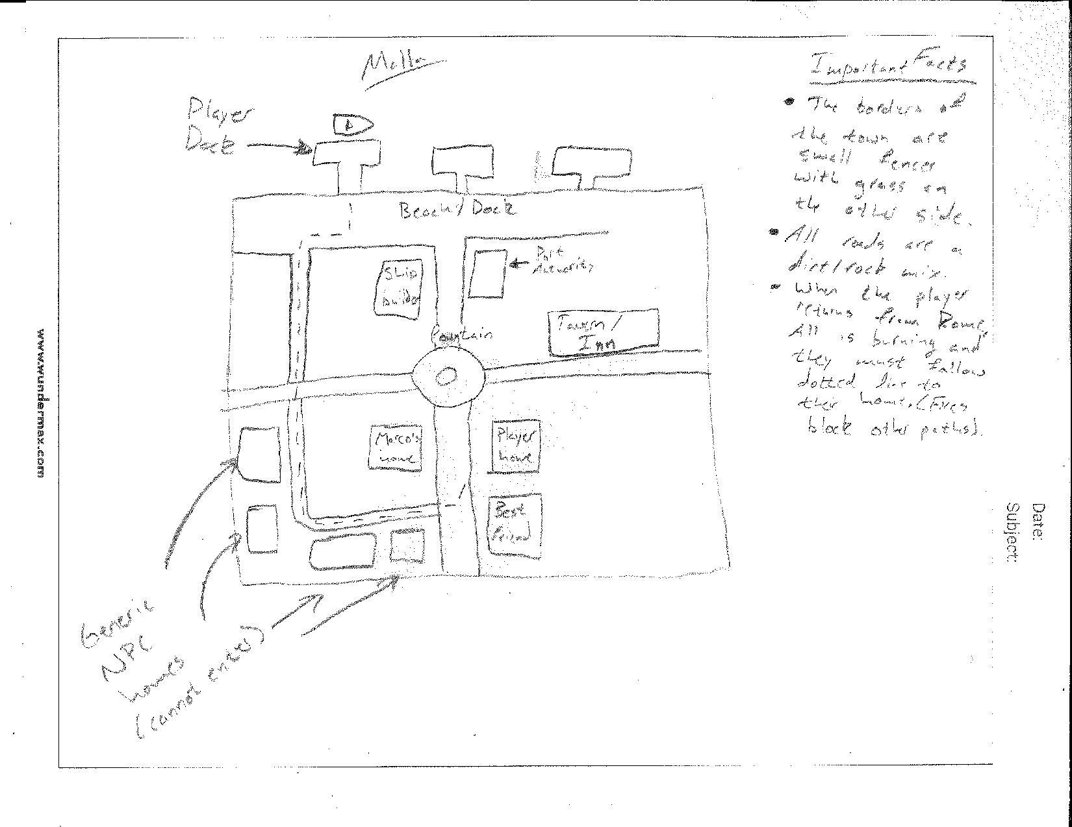

Malta is the port town that the player starts out in. In Malta, all of the roads have a dirt/stone look, with regular grass in all the areas not taken up by roads or buildings. The beach is sandy and leads to the 3 piers, one of which has the old ship stored in it. Prior to going off to Rome, the player can go into any of the shops/tavern and talk with the people at the counter, each of you responds with the template “Ciao! This is the [shop type], you can [buy store specific items/talk to potential crew/rest] here.” The player meets Jacob, Mother, Marco, and is introduced via a letter to Angel[oa]. After returning from Rome, the whole city is in flames, with a fire animation on every building and all docks except the one labeled as player dock. The player then moves along the dotted line on the map above to their home to see if their mother is still ok. This path will be the only one available and all intersections and other paths will be blocked off with flaming rubble.

**Rome**

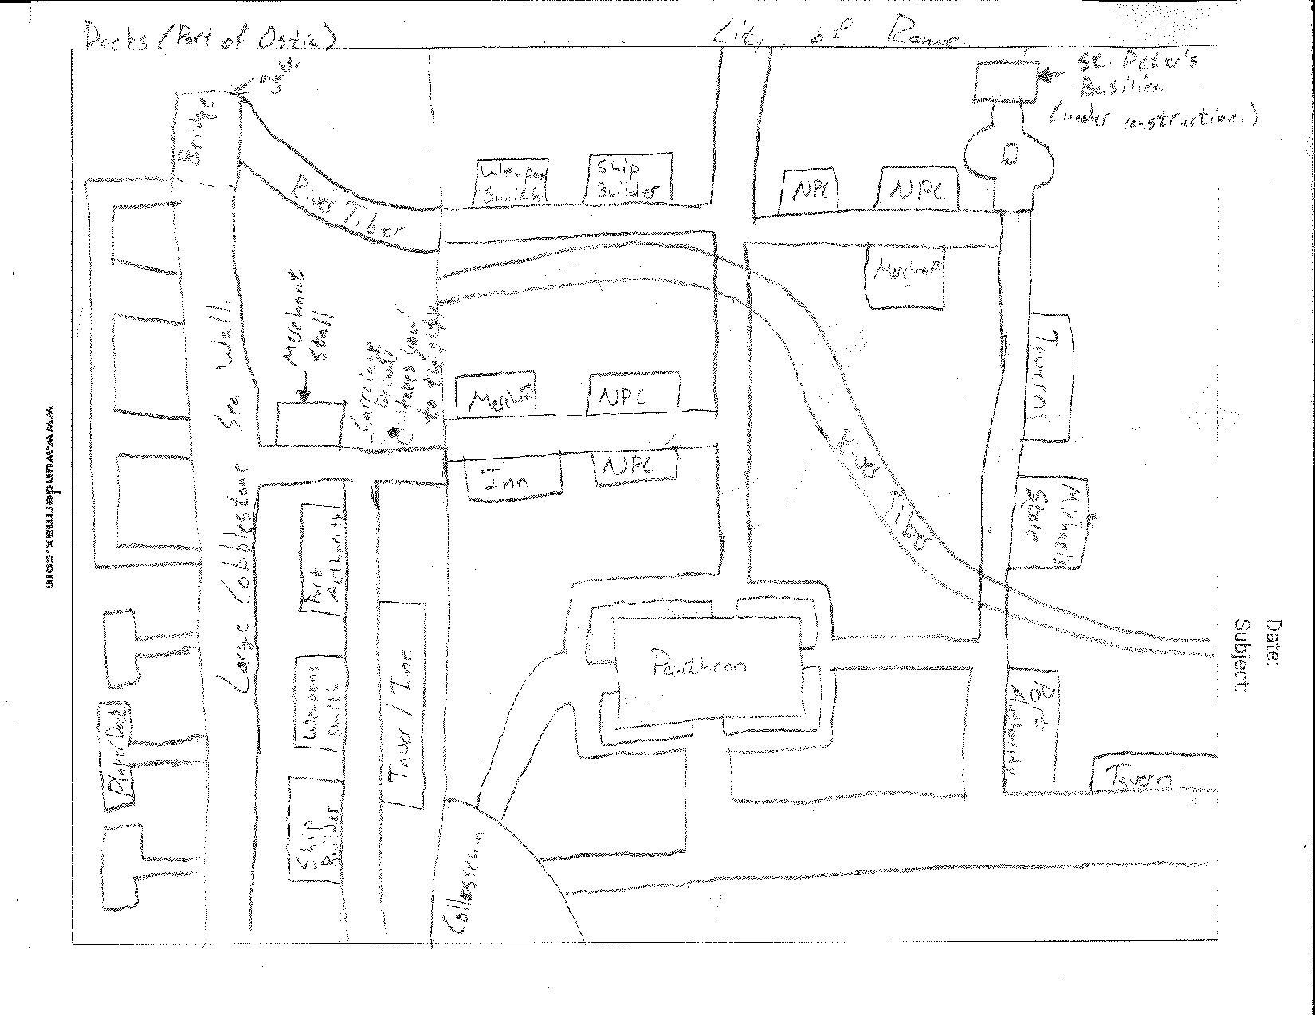

Port of Ostia

Whenever going to Rome, the player first docks in the port town of Ostia just down the River Tiber from Rome. This is a large port with many docks, as well as many of the vendors and locations that would be found at most port cities. However, the vendors here will tend to pay less for the same goods as vendors in the city will pay. On the only horizontal road the player can find a person with a horse and carriage who will take the player into the city.

Rome

Rome is one of the largest cities in the game, and includes all of the vendors that are available, as well as three unique building sites, which are the Coliseum, the Pantheon, and Saint Peter’s Basilica, which is under heavy construction during the entirety of the game, though the player will be able to walk around on the square surrounding it. All of the roads in the city are a cobblestone/brick pattern and are red in color. NPC’s in Rome are generally friendly toward the player, and are very willing to trade. Angel[oa]’s home is the NPC home closest to the Basilica and it’s interior is identical to the player’s initial home, though with a different color. Shops here have a preference towards silk and spices, and pay less for wine and artifacts. Most quests that are given out in Rome are retrieval quests, where the player will generally go and talk to merchants in other port cities to artifacts that the Papacy wants. The port authority here is a bishop, and dresses differently than other port authorities (See Characters Appendix). The player will also be told on arrival here the first time after Malta burns that the pirates have been seen heading west.

**Alexandria**

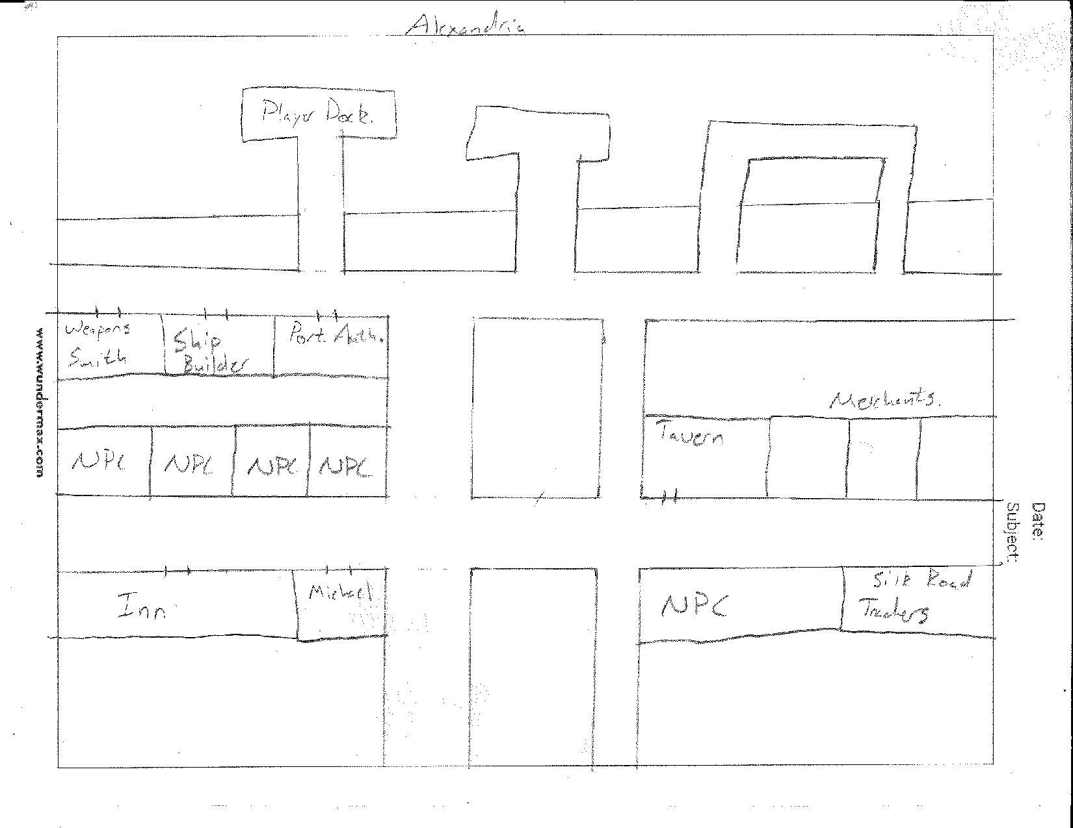

The port city of Alexandria is a medium sized city, with all of the vendors available as well as one unique building. This building is the Silk Road Trader’s Shop, and inside the player can both trade with the trader, who has some unique items and upgrades, as well as common items. The trader will also give the player a quest the first time that he meets the player, which will be a quest to deliver a large shipment of silk to the Grand Bazaar in Tunis.

The general appearance of Alexandria is that of a desert oasis. The roads are a dirt/sand texture and color and the buildings are brown in color with flat roofs. The people of Alexandria are somewhat hostile toward the player because of religious differences, though still willing to trade.

Goods that are in demand in Alexandria are wine and olive oil, and items that are are not particularly wanted are silk and spices. Quests given by the port authority are generic quest types, and he will tell you that Captain Red Jacket hasn’t been seen in Alexandria in a very long time.

**Istanbul**

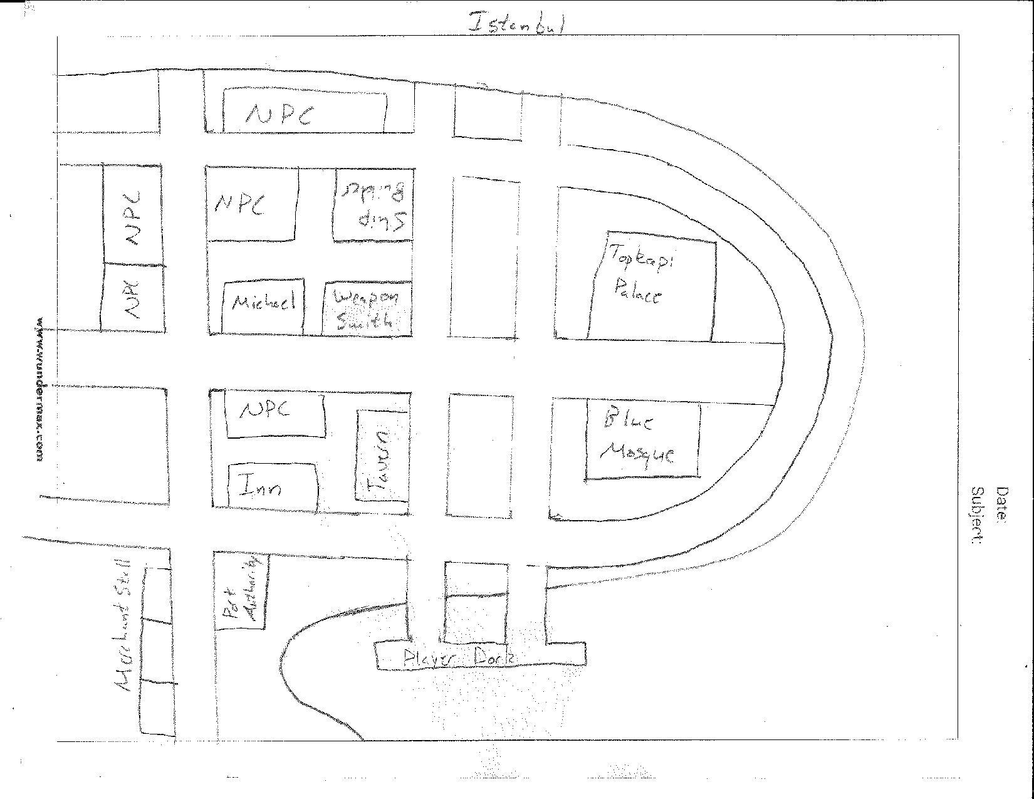

Istanbul is one of the large cities in the game, with all vendors available, as well as 2 unique buildings, being the Topkapi Palace and the Blue Mosque. At this time in history, Christian relations with Istanbul were very poor, since it had recently been conquered by the Ottomans. Because of this, the player isn’t able to go into either of the unique buildings in Istanbul, but a unique quest can be obtained by talking to the town guide outside the palace. This quest will be to smuggle an old noble out of the city at night and into Athens.

Most merchants in Istanbul will be very reluctant to deal with the player, as historically the Ottomans restricted trade with the west, though they will pay a large amount for sugar and gold. All other trade with them will generally be more expensive to the player. The tavern master here however is greek, and will be very warm and inviting to the player. After the quest, “Long Live Byzantium Part 2”, the merchants will be open to the player and trade will be normal.

The roads in the city are an old red brick style, and the houses are similar in style to those in Athens, with red clay roofs and white sides. The edge of the town is bordered by the water on one side, and the giant Theodosian Walls on the other.

**Venice**

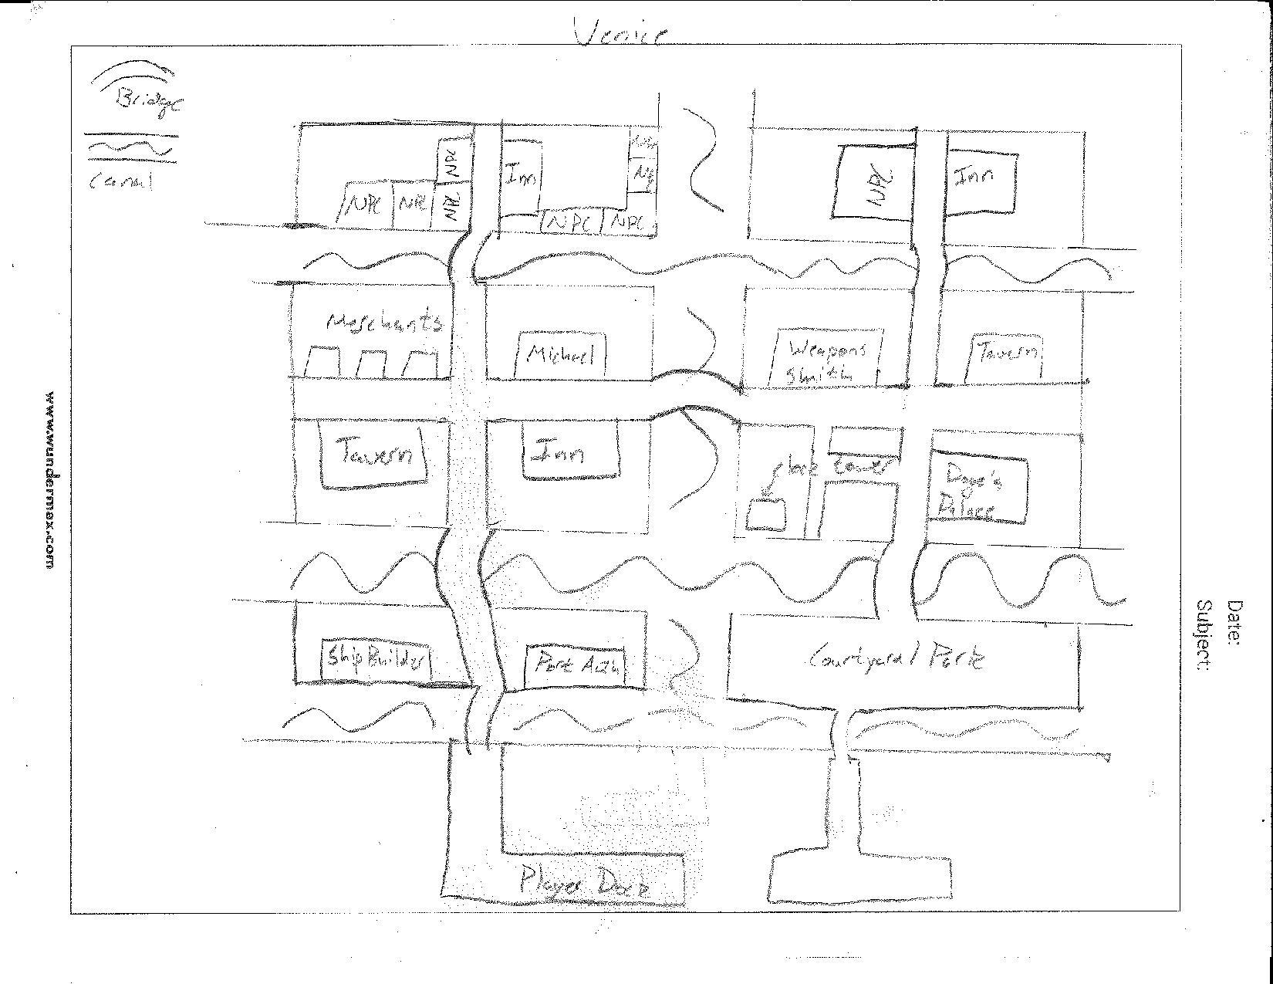

Venice is a medium sized city, with all of the vendors available, one unique location, and an extra Tavern. This extra tavern exists because it is the tavern that Marco used to own before he joined on with the player’s father. Inside, his brother runs the tavern, and upon arrival in Venice Marco will say, “I ought to see how my brother Polo is doing with my bar,” and once the player leaves the ship, Marco will be sitting at the bar in the Tavern, talking to the barkeep.

The style of architecture in Venice will be similar to that of other Italian cities, with cobblestone roads. The bridges will also be of this style, and the roofs of the buildings will have a blue-green color to them. In the southeast part of town, there is a large park with grass and trees. The unique area in Venice, other than the canals, is the Palace square, where there is a large clock tower, a church, and the Doge’s Palace. The player will not be able to enter any of these buildings, though next to the palace the town guide will stand to give the player a quest. This quest is to find out what has been causing the waters south of the city to be violent for seemingly no reason. The people in Venice will be nice to the player and very willing to trade. They will pay more for silk and gold, and will pay less for fish and wine.

**Athens**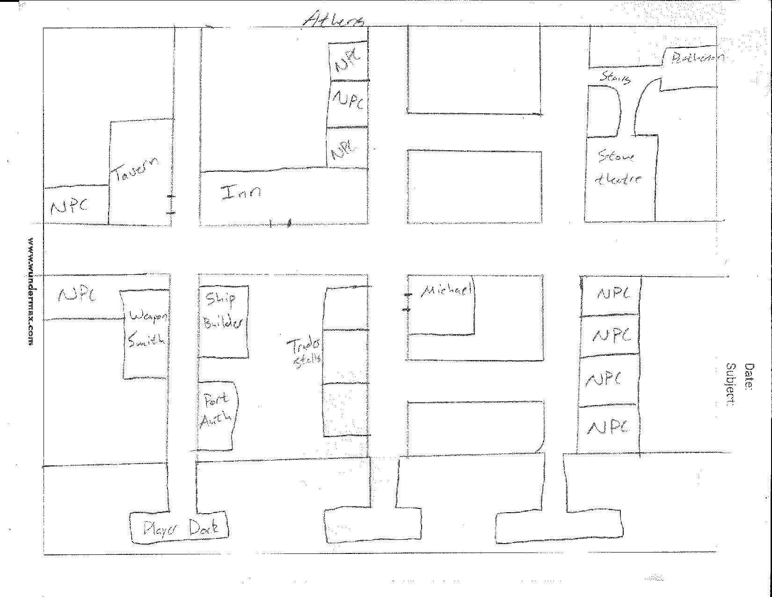

Athens is a medium sized city, with all of the vendors available and two unique buildings that they player can walk up to, but not in, due to renovations. These are the ancient Greek Parthenon and Stone Amphitheatre. Here is where the player can get a unique quest to smuggle a great amount of counterfeit coins into Istanbul as a way to disrupt their economy.

In general, the city has an old style to it, with marble buildings and white marble roads. The people of Athens are friendly toward the player and are open to all trade. Here they will pay extra for artifacts and silk, but will pay less for wine and olive oil.

**Barcelona**

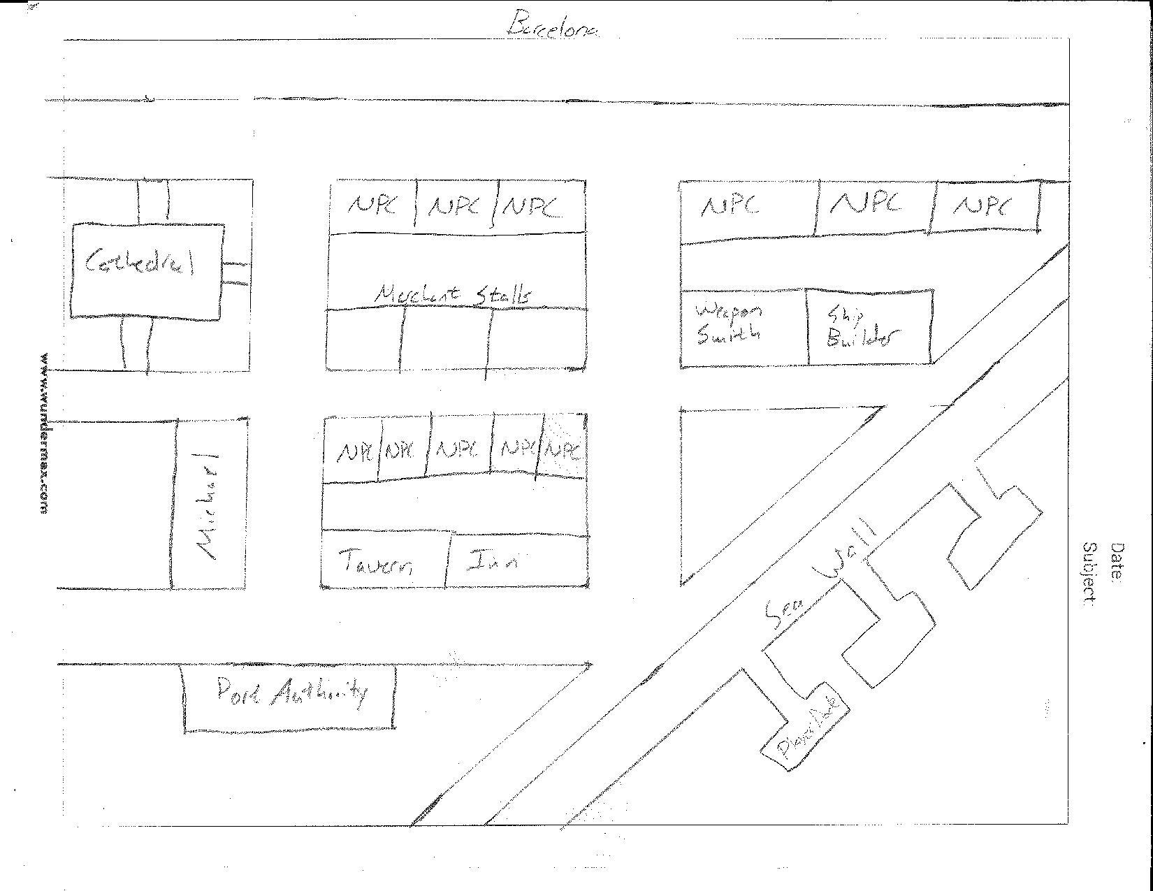

Barcelona is a smaller sized city, with all vendors available and one unique building, a large cathedral. At the cathedral, the town guide will give the player the unique quest to smuggle coded catholic texts to secret missionaries in Tangier. Trade here is open and merchants will generally pay a large amount more for silk and spices, and will pay less for gold and sugar.

The city itself is of Catalonian style, with some Arabic influence. The roads will be a multi-colored cobblestone and buildings will be vibrant colors.

**Tangier**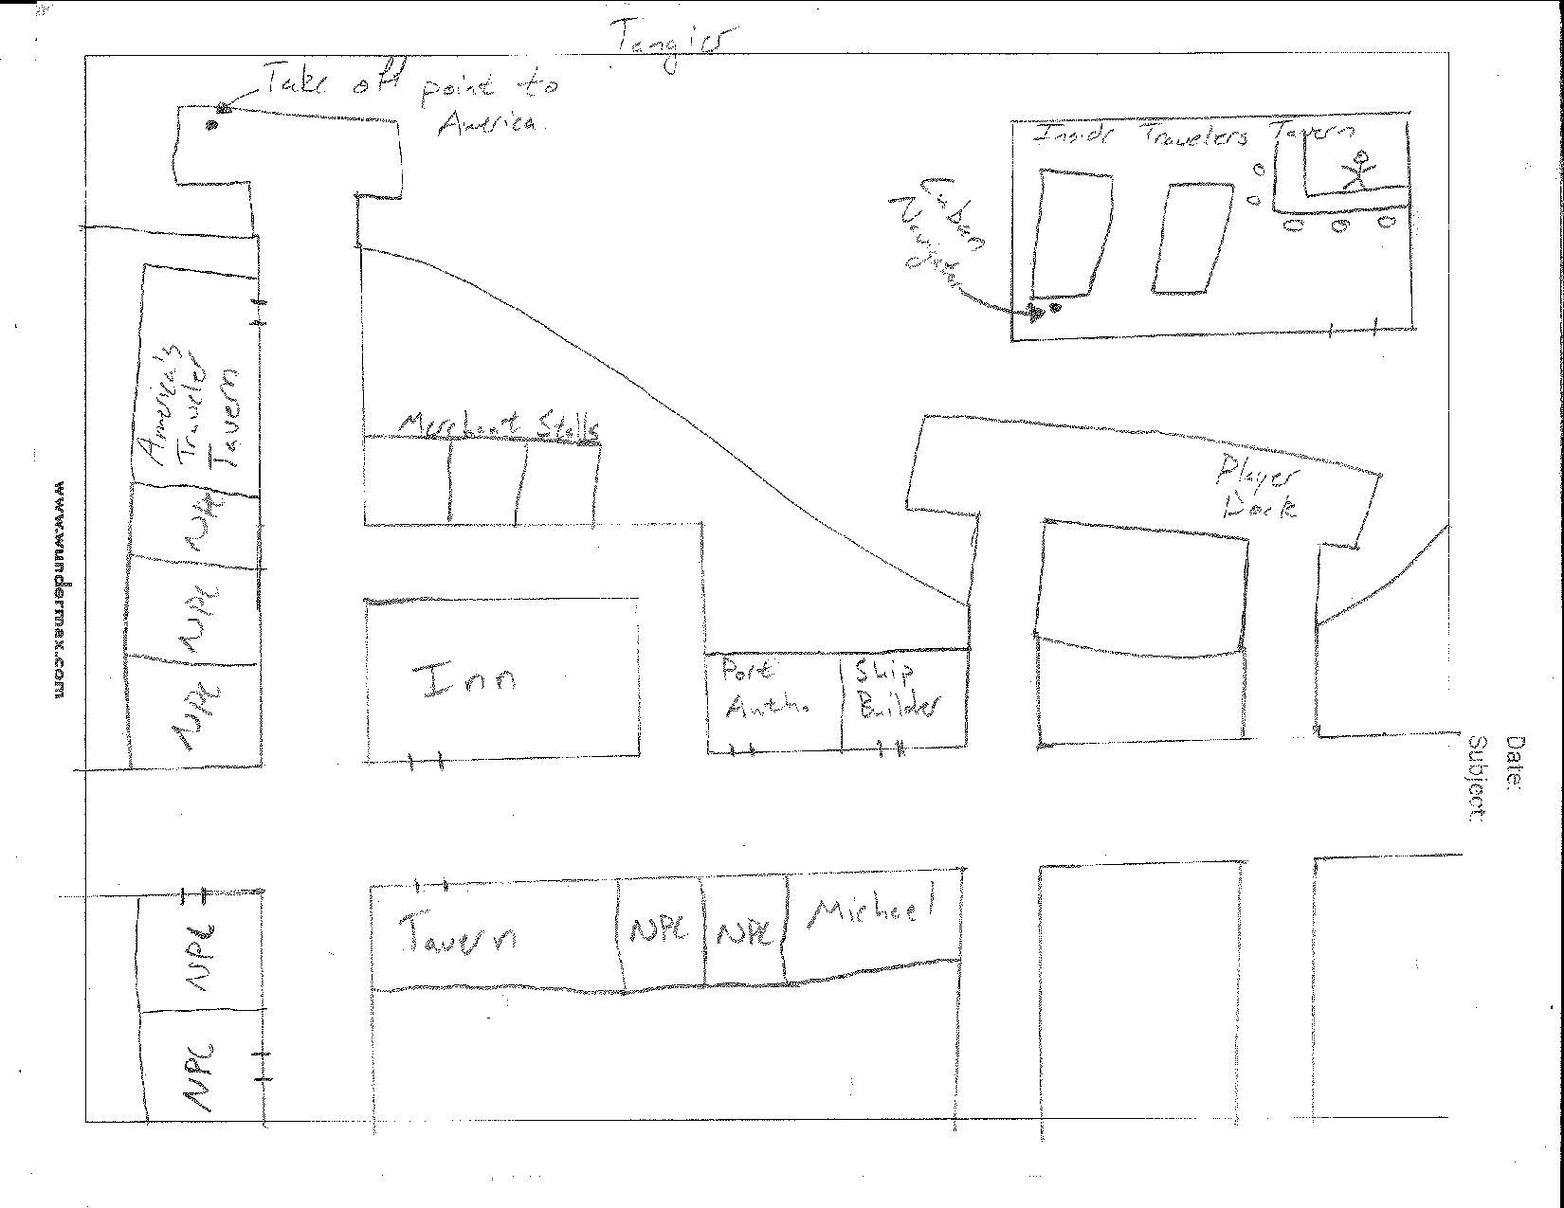

Tangier is a small port city with all available vendors, as well as a unique tavern where the player will be able to find a Cuban navigator who will take them to the America’s once the player’s ship is ready and the navigator has been payed a large amount. This will begin the player’s journey to America’s and continue the main story quest. After the first time being to the Americas, the player will only have to speak to a dockhand to be able to set off for the New World. Because of it’s importance to the story, Tangier will only be able to be accessed after the player has visited at least one other port west of Rome after the initial story questline.

Merchants in Tangier will pay very large amounts for silk and wine, and will pay less for sugar and gold. The people of Tangier will be somewhat hostile to the character, but still very open to trade. The tavern master will be an old Granadan noble however, and will speak very poorly of Barcelona.

**Nice** 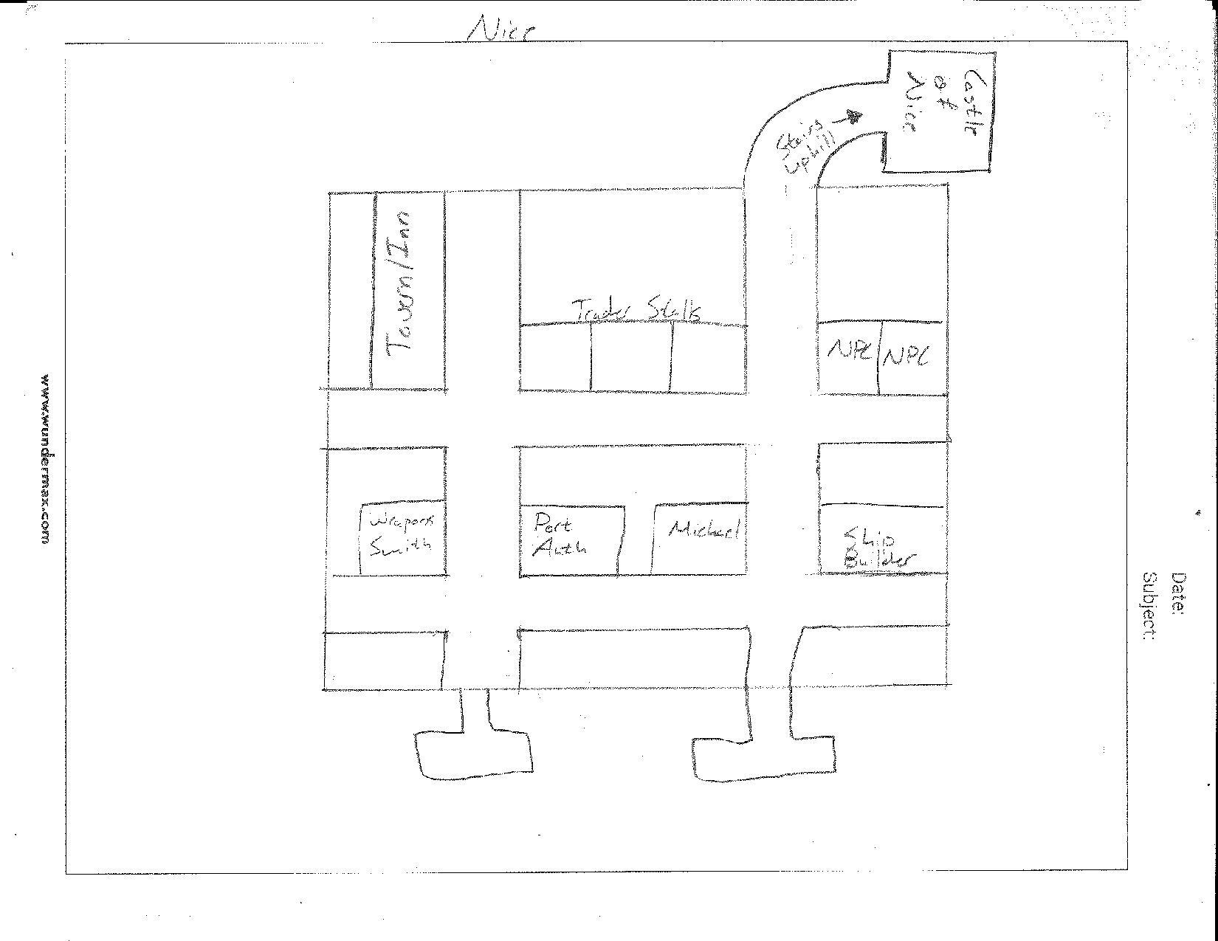

Nice is a small port city with all available vendors and one unique building that the player will not be able to enter, the Castle of Nice. The people of Nice are very particular in that they are ***not*** *French.*  There is a unique quest inside the tavern/inn, where the player will have to escape the city after Jacob accidentally calls the bar a bunch of dirty Frenchmen.Chaos then ensues, and the player will need to escape to Rome while being followed by a fleet of angry Provincial sailors.

The style of the city will be similar to the port of Rome, with stone roads generic stone buildings. Merchants here will be neutral toward the player, though very aggressive toward Jacob after the quest. Here merchants will pay more for silk road items, and less for wine.

**Havana**

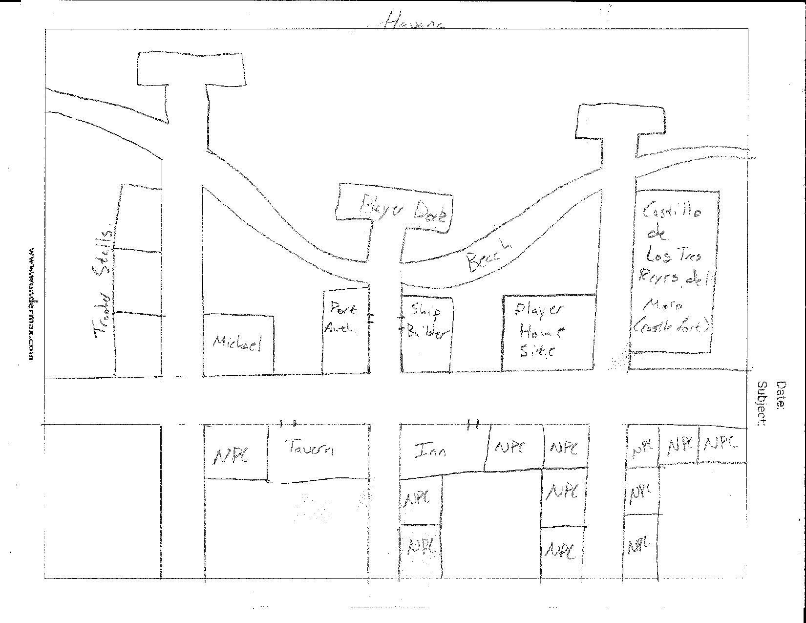

Havana is a small port city that is only available to the player after they finish the main story questline. In Havana, there are many small merchants who mainly sell fish and sugar. Exotic merchants here will occasionally have very high value furs which will sell at very high prices in Europe (see Goods Appendix). In Havana there is also one unique building, a large fortress, which will be off limits to the player, though outside there will be a town guide that will give out a unique pirate hunting mission.

In Havana there is also a plot of land that is available for purchase after the player has completed the main storyline. On this site, the player can build a large manor that will house trophies for unique quests they have completed, as well as trophies for journey milestones. This house will be customizable in color of siding and roofing, and after the completion of its construction, Angel[oa] will move in with the player. For more information about post-game quests and options see the Post-Story section of the document.

**Building Interiors**

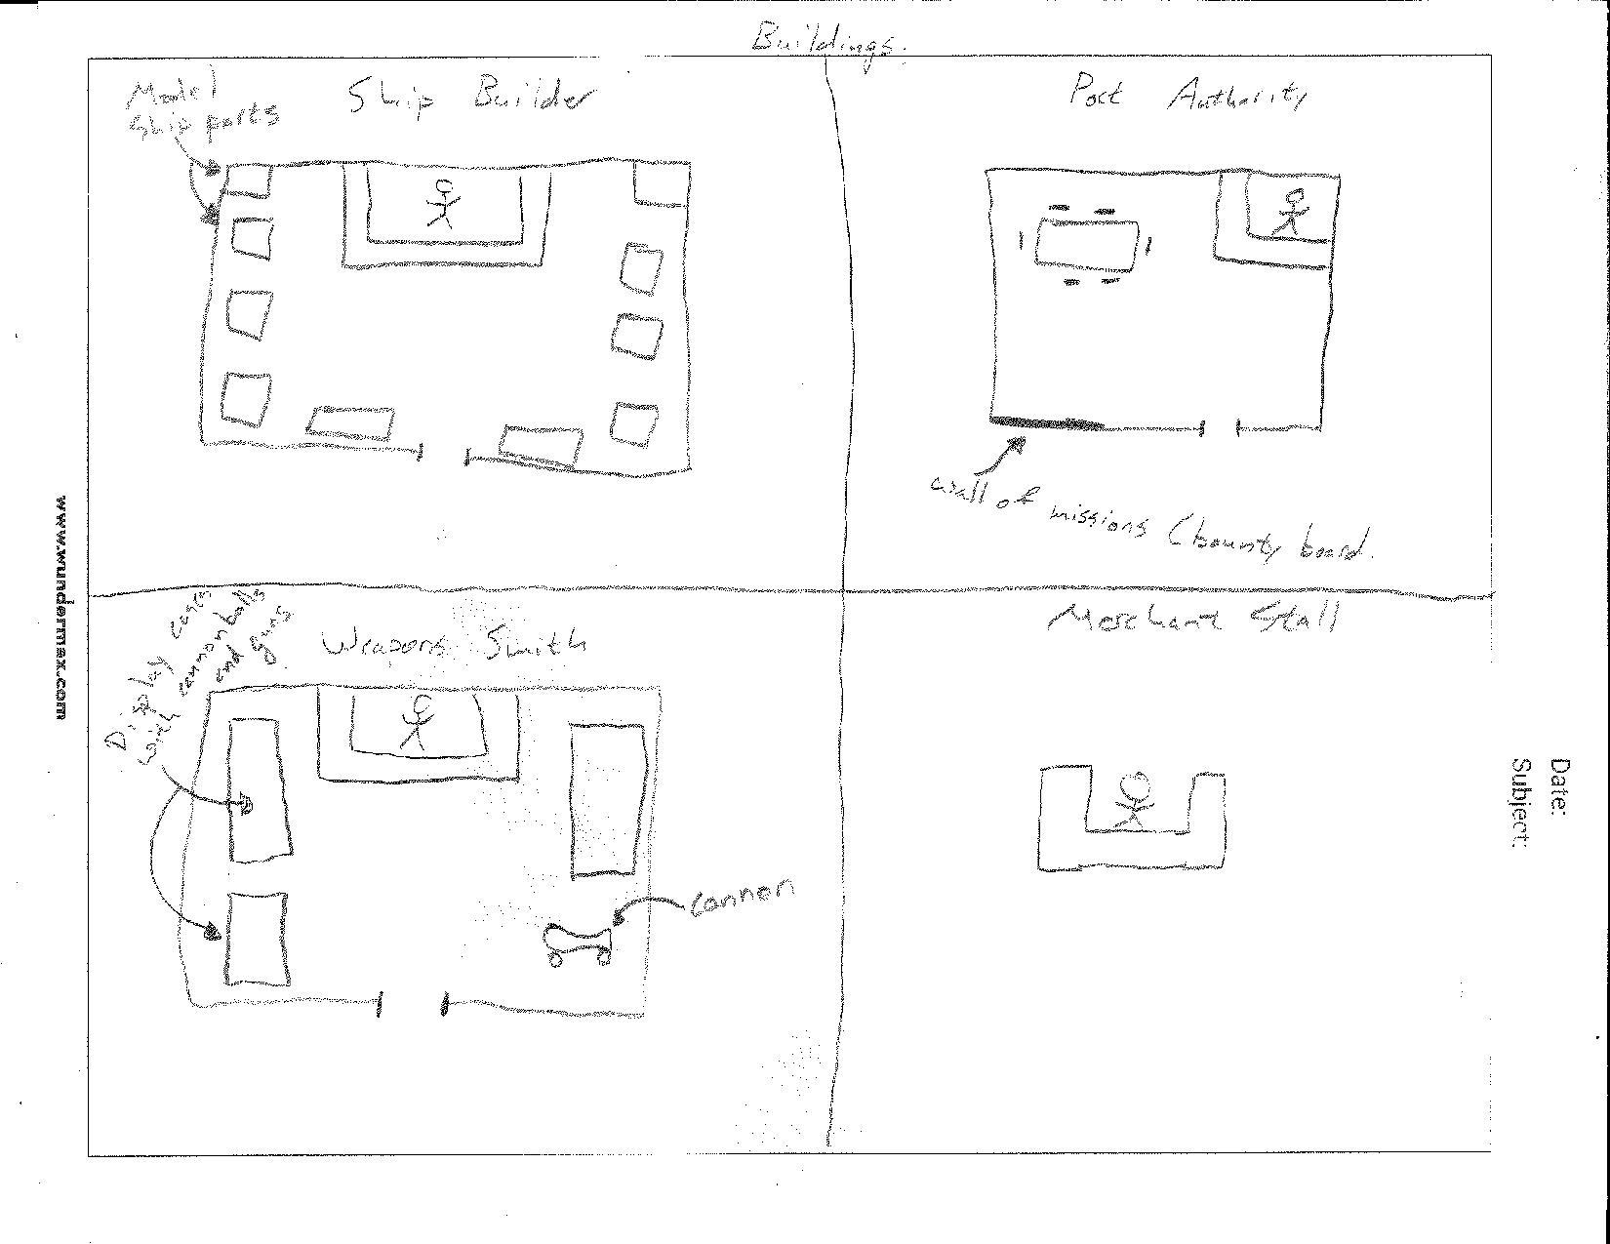

**Ship Builder**

The Shipbuilders’ stores will be single room shops with display cases containing ship parts and design papers, with a single counter with the owner of the shop standing behind it.

**Port Authority**

The Port Authorities’ buildings will be single room buildings with a counter in the corner and a table in the middle of the room. On one of the walls there will be a bounty board that will contain generic merchant quests.

**Weapons Smith**

Weaponsmiths’ shops are similar to the ship builders’, but are different in that all of them will have a cannon located in one of the corners of the building, and the display cases will contain guns, cannonballs, and designs for weapons.

**Merchant Stall**

Merchant Stalls are very simplistic, being a wooden stall with crates of goods behind it.

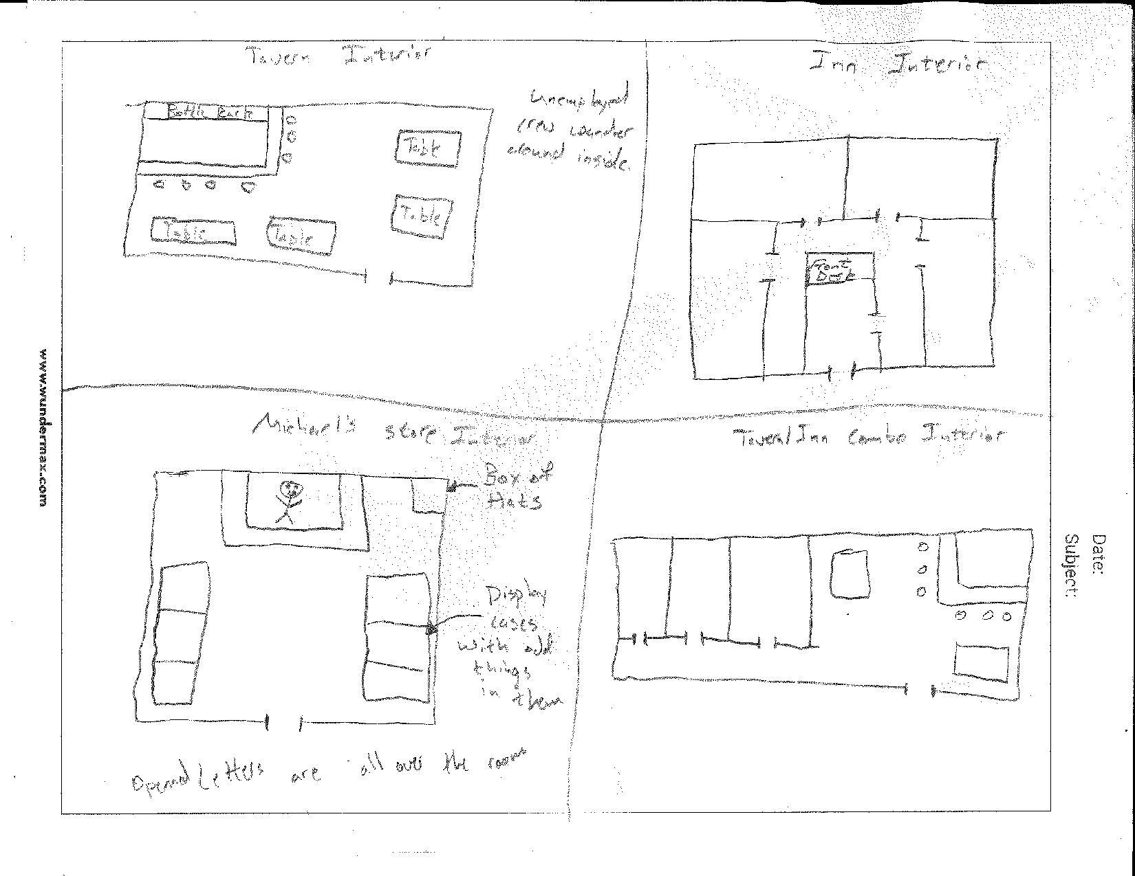

**Michael’s Store**

Michael’s store is similar to the Weapons Smiths’ and Ship Builders’ stores, with a counter in the back and display cases on the sides. However, in the display cases there are very odd items, such as piles of sand and small wooden figures with seemingly no value. In the back corner of the shop there is a box of different hats that look familiar to the player. Thrown haphazardly throughout the shop there are also dozens of opened envelopes from his brothers.

**Tavern**

Inside taverns there is a bar in the back corner with several tables placed throughout the room. In the room there are multiple sailors who can be recruited to join you in exchange for money. In Arabian cities, the floors of the bars a sandy colored stone with stone walls, and In European cities the floors are wooden with stone walls.

**Inn**

Immediately inside the doorway of all ins is a front desk where the player can purchase a room for the night. Generally, all inns will have 4 bedrooms, where in the morning the player will be able to find Marco and Jacob in the two closest rooms to the player’s.

**Tavern/Inn**

The tavern/inn combination buildings that are located in some smaller cities contain a small tavern with a bar and some tables immediately inside, and back down a hallway rooms can be found. These rooms are rented out by talking to the barkeep.

### **Travel**

Movement around the game world can be split into the following two categories. See the Time section for explanation of how long travel takes.

* Land
  + On land, the player moves around by walking or (rarely) by horse drawn carriage. The port cities themselves are easy to travel on foot by, and the the player controls how quickly the hero moves around.
* Sea
  + On sea, the player travels by boat. They travel by navigating the boat on the sea.
  + Along with navigating the boat, the player can encounter other ships, find islands, and fight pirates.
* Fast Travel
  + After completing the main game, the player can easily travel between Havana and Tangier with fast travel (see “Time” section). Since the point of the post game is to open up travel and develop a home in Havana, fast travel cuts out the middleman of waiting during sea travel.

### **Objects**

There are two major different objects for the players to utilize throughout the game.

**Goods** can be bought or sold to merchants at any port. They are found through the course of the game, and are often the focus of a quest (where a character needs you to find or acquire the good) or can be bought or sold at markets in every city. See the “Goods Appendix” for a breakdown of all the different goods.

**Ship Upgrades** are used to increase your ship’s stats and functionality. The player starts with a default ship and resources (such as the hull, cargo hold, net, cannons, sail, and crew). Throughout the game, the player collects goods that can be put towards ship upgrades. Some quests give specific ship upgrades, and some quests require certain ship upgrades before they can be “unlocked.” See the “Ship Upgrades Appendix” for a breakdown of the different ship upgrades.

### **Weather**

The game takes place in the Mediterranean area. The weather for this area includes rainy winters and hot, dry summers. One important weather element is storms, which can negatively affect the player, especially when the player is out at sea. Storms can badly damage the player’s ship, and make it more difficult to navigate the sea.

### **Day and Night**

Day and Night are drastically different in terms of lighting, but game play stays about the same.

See “Lighting” section for an in-depth explanation of lighting during day and night. Other considerations are as follows:

* Day
  + Everything is well lit and easy to see.
  + Much easier for any type of travel.
  + All other characters are awake.
* Night
  + Most elements of the game aren’t well lit.
  + Travel by ship is nearly impossible. This will make the player want to drop anchor and sleep until the next day.
  + Some characters aren’t awake or around.
  + The taverns/bars become livelier.

### **Time**

Time impacts the game in the following ways:

* 12 minutes of real time is 1 day in the game world
* Sleep
  + Sleep is a save point, which provides the player with the motivation to sleep.
  + The player decides when to sleep by either.
    - Going to an inn or players home.
    - Put down the ship’s anchor to sleep.
  + For sleep, the screen fades to black, and then fades back in. No real time is spent on sleep.
* Travel time
  + On average, it takes about 15 minutes to travel from one port city to the next (some are father, some are shorter) .
  + It takes about 1 day in the game world to travel between cities.
  + Travel to the Americas takes around 30 minutes of real time. This 30 minutes is interspersed with fighting pirates, cutscenes, and checkpoints.
* Fast Travel
  + Once the player reaches the Americas, travel time back and forth (between the Havana and Tangier) is cut down to around 3 minutes of real time. This allows the player to come back and forth much more often and trade easily.

## 

## 

## **Camera**

### **Overview**

The game uses a Pokemon-esque camera style to display the world to the player. This is done to minimize art modeling for the background by eliminating multiple angles, as well as to enhance the level of detail we can put into the background art.

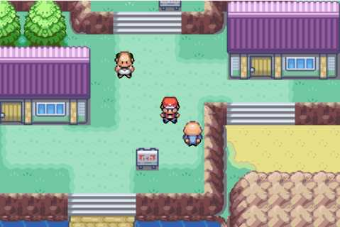

*Image: https://r.mprd.se/media/images/44874-Pokemon_Fire_Red_(U)(Squirrels)-2.jpg*

## **Game Engine**

The game engine that will be used to create the game is the Unity engine, and we will be using the 2D feature set of the engine.



*Image: https://unity3d.com/files/images/ogimg.jpg?1*

### 

### **Overview**

Unity is a cross-platform game engine developed by Unity Technologies, and is one of the premier game engines on the market. It has been used to create massively intricate games such as Kerbal Space Program, platformers such as Cuphead, and card games such as Hearthstone.

### **Game World Mechanics**

The game engine will keep the following rules in place for player movement.

1. The player cannot walk on water
2. The player cannot move through objects (walls, ships, people, etc.)
3. The player must remain on the ground (no climbing up walls, flying in the sky, etc.)
4. The player can transition between environments by doorways, or by boarding/docking their ship.
5. Other human NPCs will follow the same rules as the player.

The game engine will keep the following rules in place for the ship movement.

1. Ships cannot travel through land
2. Ships cannot move through other objects (rocks, ships, land masses, etc.)
3. Ships cannot immediately change speeds, they gradually increase and decrease speed (unless they run into an object they cannot move through)
4. Ships must remain in the water (no flying in the sky)

### **Water**

Players won’t interact with water in port cities. When at sea, water will be made of repeating blue tiles. The water may display different patterns depending on weather, location, and the presence of the kraken.



### 

### **Collision Detection**

Collision detection is built in to Unity2D with the Collider 2D component. The Collider 2D component lets you define boundaries in your sprites and environment, and handles the collision detection by leaning on defined parameters.

## **Lighting Models**

### **Overview**

The lighting model for the game will consist of 3 modes - indoor lighting, outdoor (daytime) lighting, and outdoor (night) lighting. There is also a special mode, storm, which is only triggered by in-game weather events.

### **Lighting Model Detail - Indoor**

Everything will always be bright when the player is inside a building. All indoor environments are lit with torches/lanterns, and it will always be the same level of brightness. Any windows to the outside environments will reflect what time of day it is (dark windows for night or light windows for day).

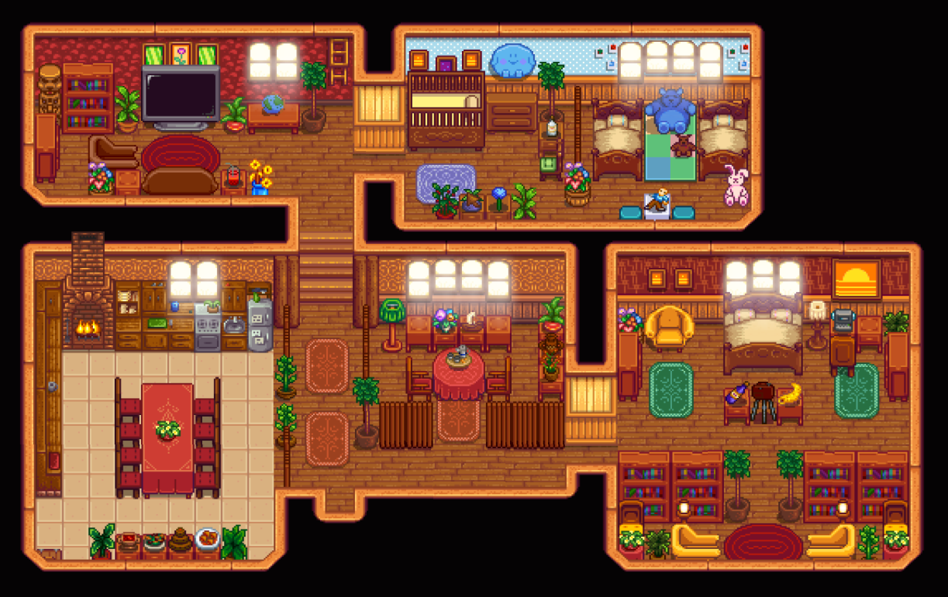

*Image: https://i.imgur.com/2WnmWrn.jpg*

### **Lighting Model Detail - Outdoor Daytime**

Everything outside will be bright during the daytime. The world is lit by an overhead sun that isn’t visible. Everything will be the same level of brightness, except for covered areas. Objects cast shadows normally, and always at the same angle.

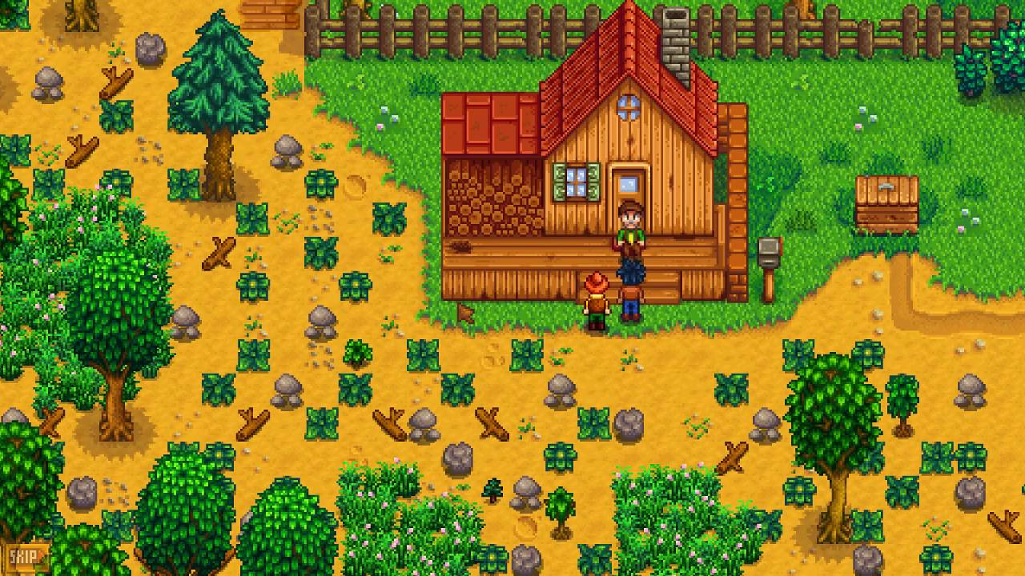

*Image: https://i.ytimg.com/vi/XxO3qG20-aY/maxresdefault.jpg*

### **Lighting Model Detail - Outside Nighttime**

Everything outside will be dark with a blue tint during the nighttime. There is a small amount of light cast by the moon and the stars, but not nearly as much as during the day. Fires, used in lanterns and torches, cast light out into the darkness that falls off the farther from the object it travels.

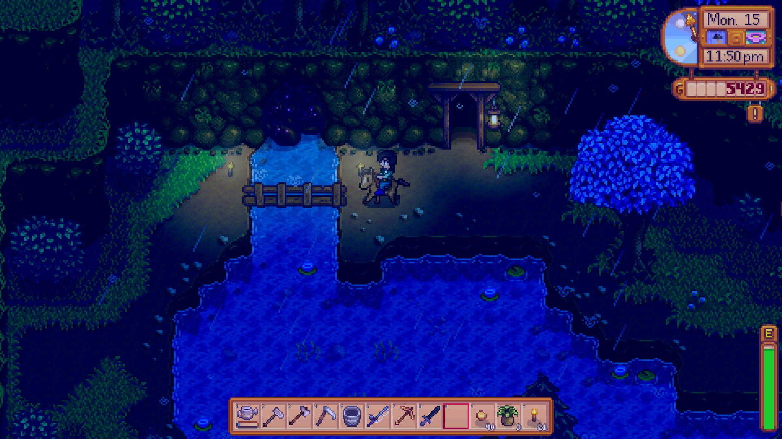

*Image: https://s3.amazonaws.com/zam-www/assets/editorial/2016/03/2016-03-06_00002.jpg*

### **Lighting Model Detail - Storm Nighttime**

Everything outside will be dark with a blue tint during storms. There is a small amount of light cast by the moon and the stars, but not nearly as much as during the day. Fires, used in lanterns and torches, cast light out into the darkness that falls off the farther from the object it travels. There will be small particle animations of rain and occasional flares of light from lighting as the storm continues.

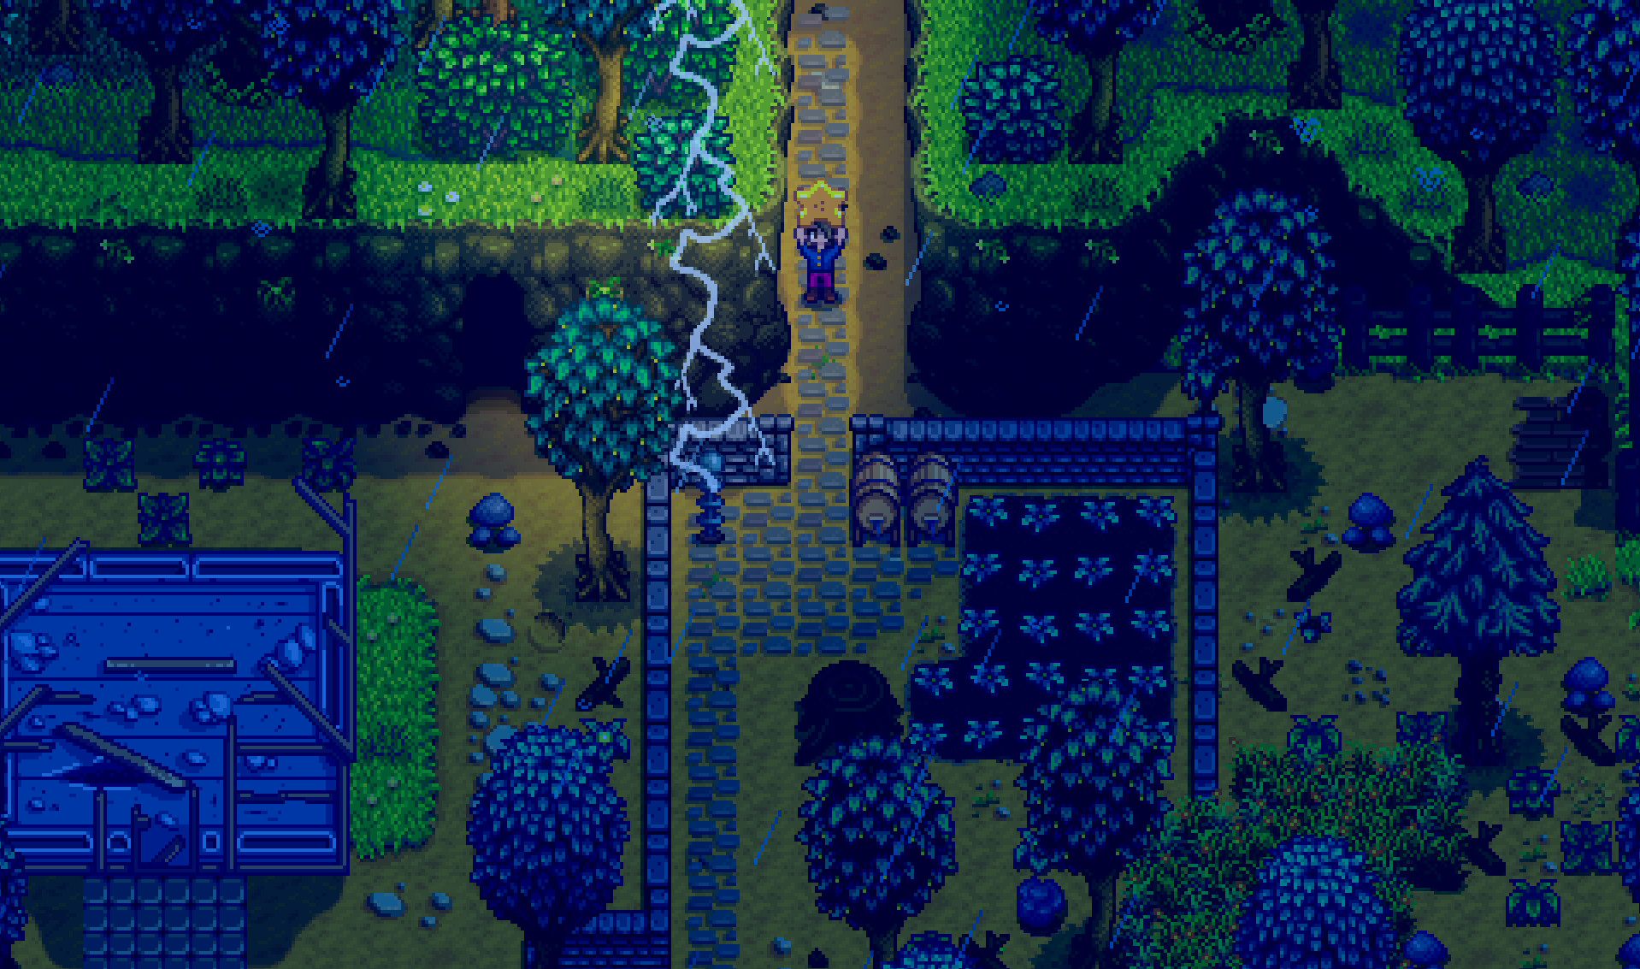

*Image: http://cdn.akamai.steamstatic.com/steam/apps/413150/*

*ss_d836f0a5b0447fb6a2bdb0a6ac5f954949d3c41e.jpg?t=1454713655*

# **Narrative Story**

A short summary of the narrative story is provided below. For a more in-depth story, see the Story Appendix.

The player is the captain of a small ship, hailing from a city on the coast of Malta, who has always dreamed of sailing the open seas and reaching the New World. The spirit of adventure and sense of longing to explore is what drives them. In order to build up their ship and crew in order to survive the long a treacherous journey, the player decides to take their small boat to the other surrounding coastal cities. They start their journey from Malta to Rome, and as they leave, they think nothing of the unassuming pirate ship entering the port they just left from. Upon return, they again dismiss the pirate ship leaving the port as they’re entering….that is, until they reach home. Our hero walks to their village and sees...nothing. The pirates have pillaged their home and left nothing in their wake. Burning with anger, fear, and sadness, our fearless hero makes it their goal to avenge their family. The ship captain knows that the pirates will eventually also cross the Atlantic to reach the Americas. Thus begins one ship captain’s quest for revenge and exploration.

# **The World Layout**

## **Overview**

The game world is centered on the Mediterranean Sea, but includes travel to the Americas, namely Cuba. There are 11 port cities that the player can sail between (detailed in the Port Cities section of the Single Player Game).

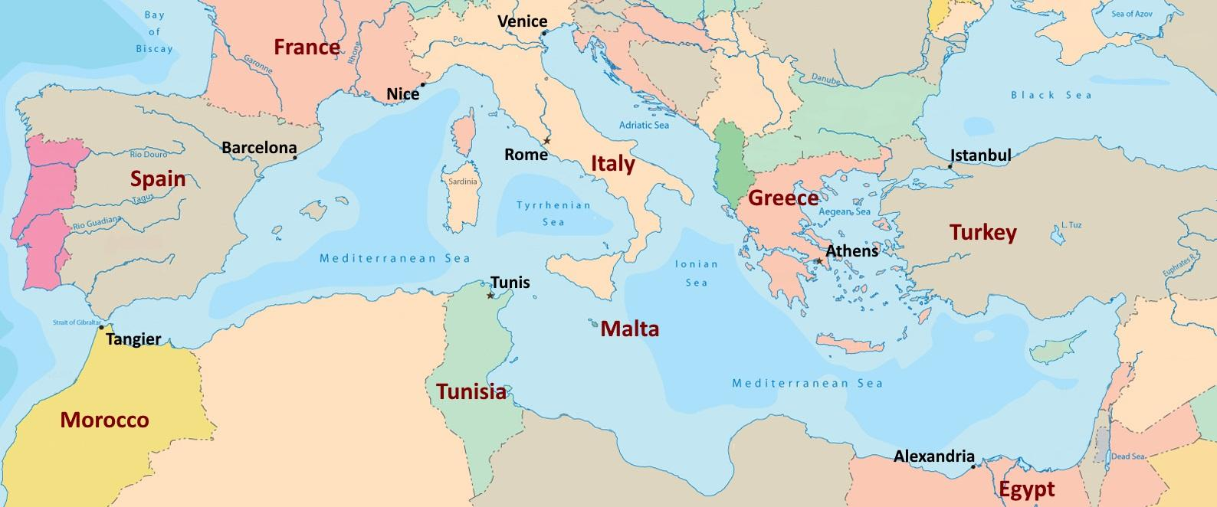

***Image: Custom***

# **Game Characters**

## **Overview**

List of specific characters (See the “Character Appendix” for a breakdown of all the different specific characters)

* Hero
* Captain Red Jacket
* First Mate (Jacob)
* Mother/Father
* Love Interest (Angelo/Angela)
* Ghost
* The Kraken
* Barkeepers
  + Marco’s Brother
* Merchants (Michael)
* Shopkeepers
* Shipbuilders
* Port Authorities
* Village Idiot
* Sailors/Crew
* Pirate Crew
* Town Guides
* Marco

## **Hero Customization**

The player will have the option to customize the Hero they play as. They will have the ability to change:

* Gender
* Skin color
* Hair color
* Hairstyle
* Shirt
* Pants color

## **Defeating the Pirates**

The player will constantly be trying to track down Captain Red Jacket, as the main storyline guides the player in this direction. Meanwhile, the character will also be fighting other pirates while attempting to track down Red Jacket’s ship

# **User Interface**

## **Overview**

The game will have a very functional UI, and will overlay information over the game world to add description to the environment around the player.

## 

## **Menus**

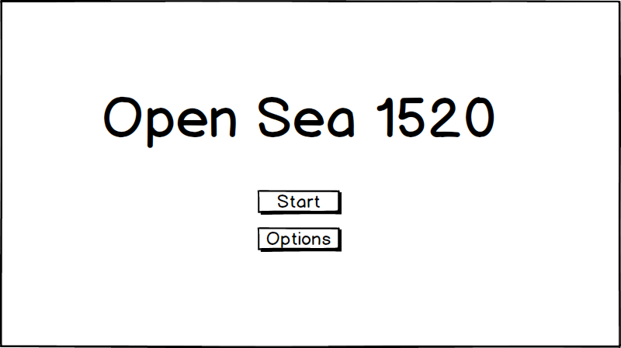

*Title Screen*

General opening screen. Lets the player start the game, or change their options.

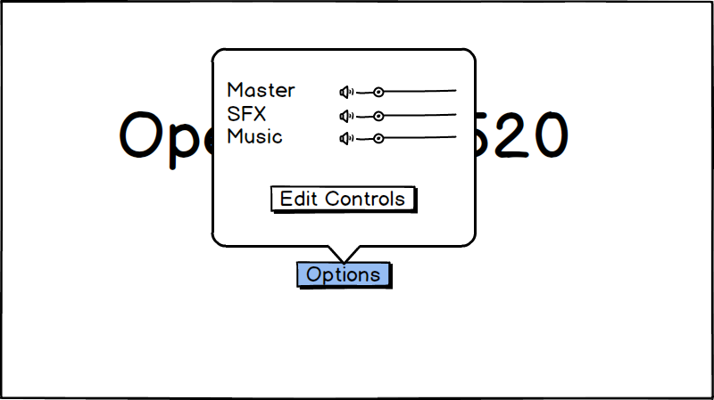

*Options Dialog*

Lets the player adjust the game volume levels, or edit the controls.

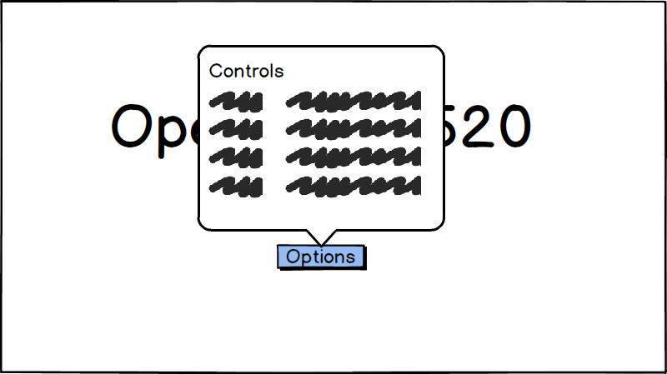

*Controls Dialog*

Lets the player adjust the key mappings for the controls.

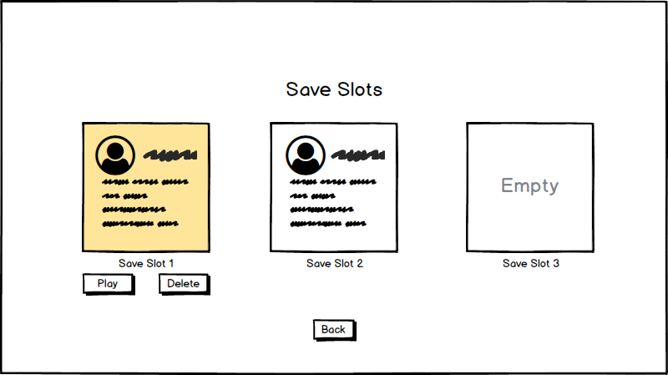

*Save Slots (continue)*

Lets the player select the save slot they want to play. They can play or delete a save.

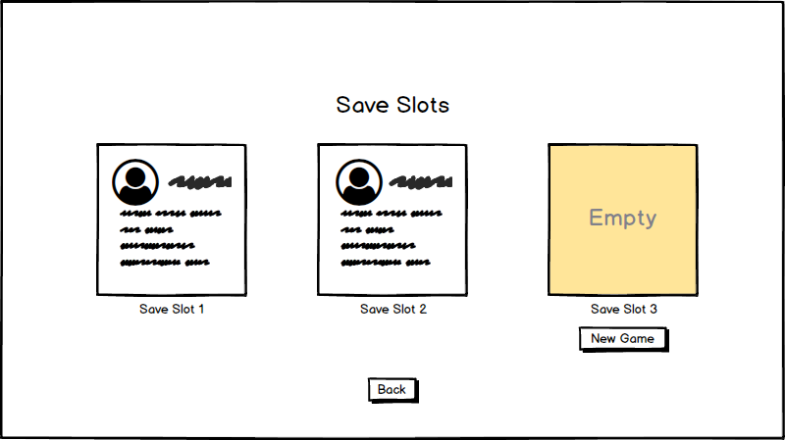

*Save Slots (new)*

Option for creating a new save slot.

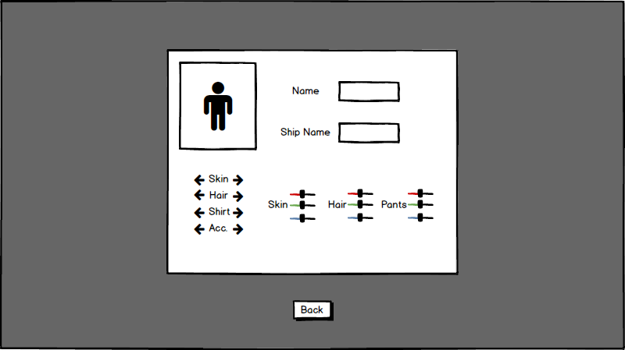

*Character Creation*

General character customization. Player name, ship name, looks, and colors.

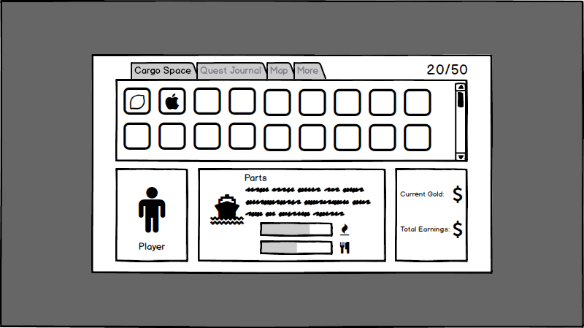

*Menu (Inventory)*

Player inventory. Amount of space left in cargo hold is show in the upper right corner, and beneath it are the actual items in the cargo hold. Shows a player portrait in the bottom left. The bottom center component displays information about the parts of the ship, as well as the player’s food and fuel levels. The bottom right component displays information about the player’s current gold, and total earned gold.

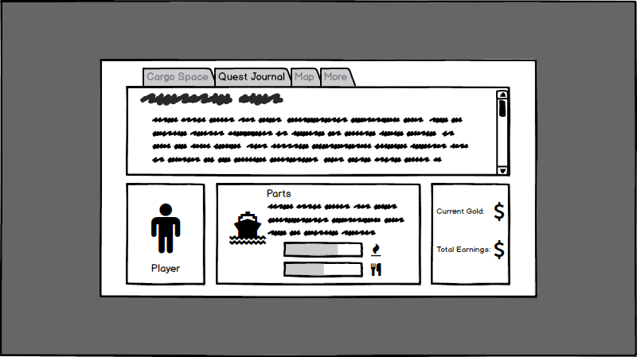

*Menu (Quest Journal)*

The Quest Journal details completed and in progress quest progression.

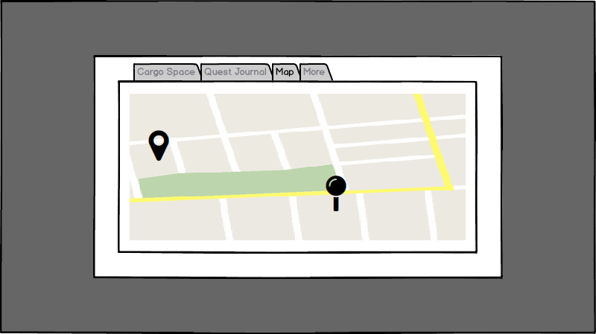

*Menu (Map)*

The Map shows the player’s position on the world map, along with main quest indicators (see the Map appendix).

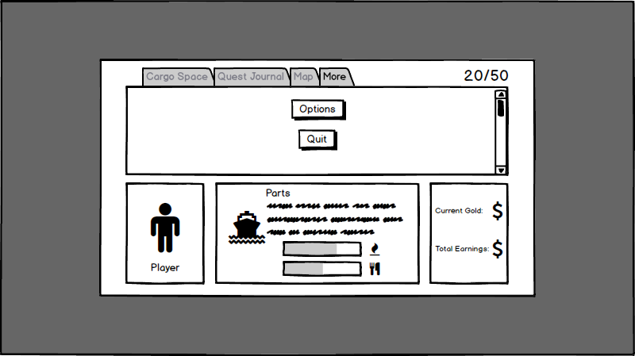

*Menu (More options)*

More options gives the player the choice to edit sound/control options, or quit the game.

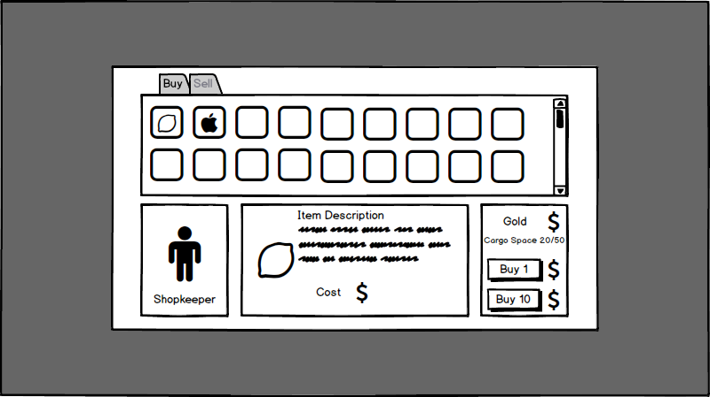

*Shop (Buy)*

Shopkeeper buy menu. Clicking on an item will display more information in the center component, as well as its cost. The bottom right component lets the player buy amounts of the selected item.

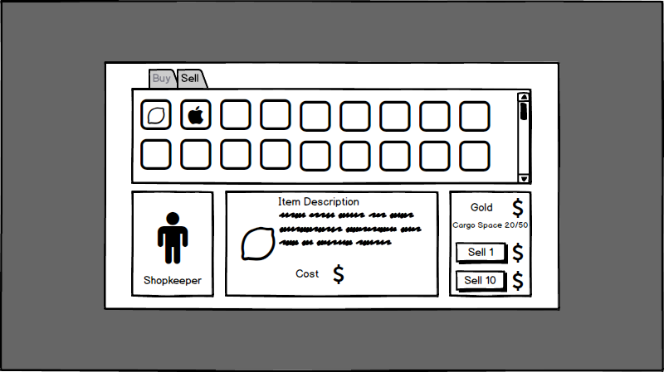

*Shop (Sell)*

Shopkeeper sell menu. Items displayed are items in the player’s cargo hold. The player can select and sell their goods to the shopkeeper.

## **Game World**

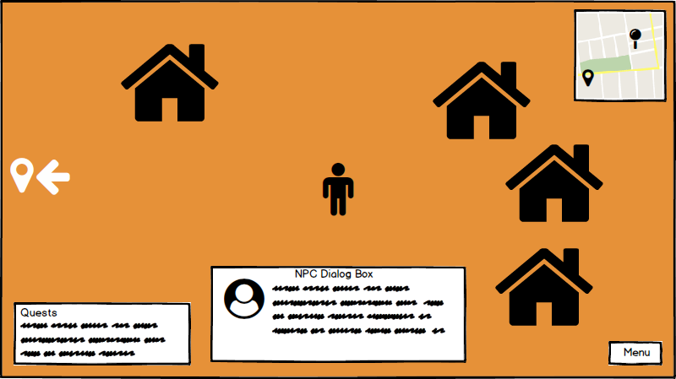

*Land*

The general land environment user interface. The player remains centered on the screen. Port city minimap appears in the upper right corner. Quest markers appear on the sides of the screen and the minimap. Active quest details appear in the lower left. Any dialog with NPCs appear in the lower center. The menu button in the lower right brings up the inventory.

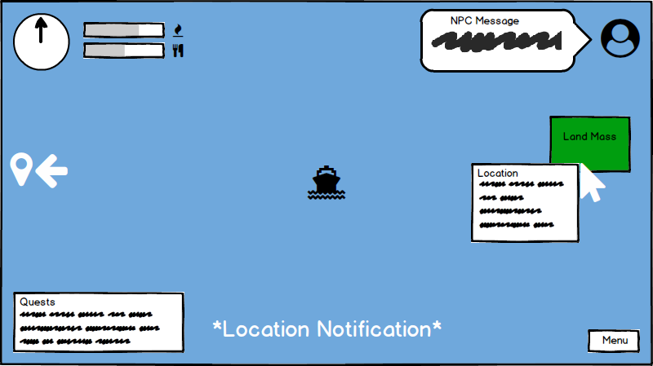

*Ocean*

The general ocean user interface. The ship remains centered on the screen. The upper left gauge displays your speed. Next to it are the sliders displaying levels of food and fuel. NPC messages appear in the upper right. Quest markers appear on the sides of the screen. Active quest details appear in the lower left. When the player arrives in proximity to a location, the name fades in and out in the lower center. Mousing over any land masses provides location details. The menu button in the lower right brings up the inventory.

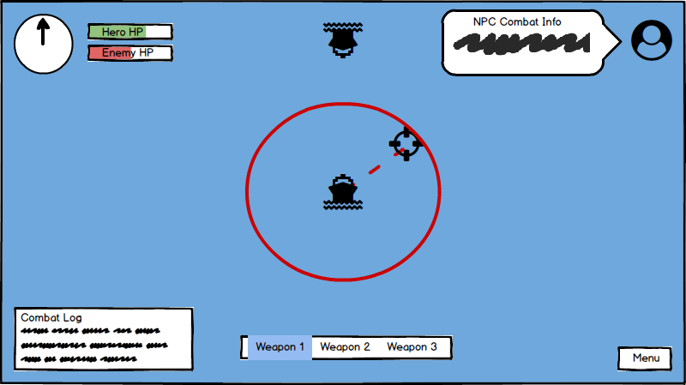

*Ocean (Combat)*

The combat ocean user interface. The ship remains centered on the screen. The upper left gauge displays your speed. Next to it are the sliders displaying the health points of the hero and enemy ships. NPC combat messages appear in the upper right. A log of combat details appear in the lower left. The weapon selection box appears in the lower center. Moving the mouse moves the targeting crosshairs, and displays the range of the selected weapon. The menu button in the lower right brings up the inventory.

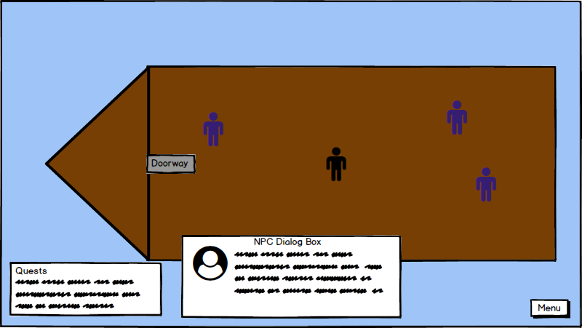

*Ship*

The ship user interface. The player remains centered on the screen. Active quest details appear in the lower left. Any dialog with NPCs appear in the lower center. The menu button in the lower right brings up the inventory.

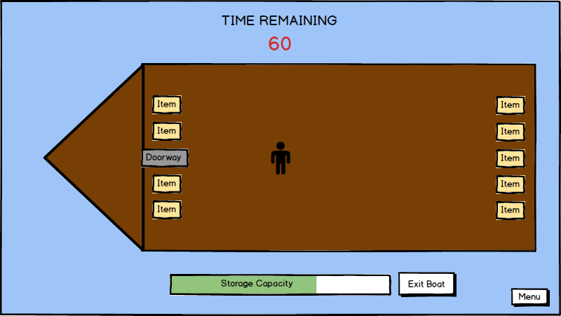

*Ship (Pillaging)*

The ship pillaging user interface. The player remains centered on the screen. Time remaining before the ship sinks is displayed in the top center. The player’s ship’s storage capacity is displayed in the bottom center. The exit boat button is displayed next to the storage capacity. The menu button in the lower right brings up the inventory.

# **Combat**

## **Overview**

Weapons

* Ship Based Weapons
  + Cannons
    - Fire cannonballs at other ships to decrease the ship’s health
    - Medium range
    - Each hit does 10 damage towards the target’s health bar
  + Naval Ram
    - Sharp spear built into the front of the ship; run into the side of the ship in order to deal the damage
    - Very short range
    - Each hit does 20 damage to the target’s health bar
  + Boarding Gun
    - Launch a harpoon with a rope attached to it in order to pull the ship in closer
    - Medium range
    - Each hit does 5 damage, but it also yanks the affected ship in closer to the firing ship

## **Ship Combat**

* Each ship will be given a number of hit points based on the strength of its hull.
* The levels of a hull range from 1 to 5 and values for hit points are 100, 200, 300, 500, 1000 in increasing level order.
* Once an enemy ship's health has been reduced to zero, the Hero has an option to then board the ship in order to pillage the resources on it.
* If the Hero’s ship is reduced to zero health, then the screen will turn black and fade in to see the Hero back at the most recently used port standing outside the shipbuilder building. The Hero will be notified that the shipbuilder had found them at sea and has taken them back and repaired their ship (for a fee).

## **Pillaging**

* Once the Hero board a ship, they will be given 60 seconds to search the ship for resources to take back onto the Hero’s ship.
* At this point, the gameplay will switch from controlling the ship at sea to controlling the Hero on a ship.
* Once the 60 seconds expire, the Hero will be kicked off the ship and then the the gameplay will convert back to the player controlling the ship at sea. Also, the enemy ship will be seen sinking into the ocean. Once the ship is sunk, the player will be able to move the ship again.
* The hero cannot collect more than the current capacity of the cargo hold minus the amount of resources on the Hero’s ship.

# **Musical Scores and Sound Effects**

## **Overview**

The game will consist of a combination of looped musical scores and triggered sound effects. The musical scores will be minimalist, and will all mostly be variations on the title theme.

## **Sound Effects**

The following sound effects are going to be included in the game.

General sound effects:

* Text scrolling (during conversations)
* Menu interaction
* Inventory interaction
* Transition from sleeping to game world
* Storms
* Seabirds

Sound effects on land:

* Walking
  + Grass
  + Sand
  + Wood
  + Stone
* Door opening/closing
* Church Bells
* Bar noises
* Waves crashing against the shore
* Fire crackling

Sound effects on boats (player):

* Walking
  + Wood
* Door opening/closing
* Creaking of wood on the ship
* Waves crashing against boat

Sound effects on water (ships):

* Ship moving through water
* Cannon/rifle fire
* Running into objects
* Running into ships
* Dropping anchor
* Picking up anchor
* Pirates nearing

## **Main Scores**

* Title Theme
* Overworld
* Sailing
* Combat
* Storm
* Port Cities
  + One score for each port city
  + Same melody, but played with a different lead instrument
* Tavern

## **Character Themes**

* Angel[oa]
* Jacob
* Michael
* Red Jacket
* Kraken

## **Musical Elements**

The main scores and character themes will be simplistic in nature, and are all based upon variations of the title theme. Common instrumentation throughout the scores include a reliance on accordions and rhythmic drums, leading the listener to feel a pirate-ey, seafaring-esque theme emerge.

# **Single-Player Game**

## **Overview**

You are a merchant sailing a ship around the Mediterranean. The direction of gameplay is mostly undirected, players are left to do what they want to.

## **Sailing**

The main character owns a ship, and the player can use it to go between port cities. Sailing uses up resources (food, fuel) and requires the player to navigate a semi-randomized path. The path will have a small amount of hazards (rocks, ice) and may have random encounters such as pirates, krakens, and islands. The path may be influenced by quests the player is currently pursuing.

## **Storage**

Players store items in their ship’s cargo hold. Similar to Minecraft’s inventory storage system, the cargo hold has a limited amount of slots. Each slot can only hold one type of item, but each item can stack up to a certain amount.

## **Fishing**

Players are able to cast out a net attached to their ship while they are within a port city. Based on the level of the net, different amounts of fish are collected every hour. Once the ship decides to set sail the net is automatically brought back onto the ship and any fish that were caught are collected into the ship’s cargo.

## **Port Cities**

Players walk around in ports, interacting with NPCs (for port layouts, refer to the physical world section). Some NPCs will trade with the player, while others will offer quests, or give the player information about the town.

## **Trade**

### Shopkeepers

* Shopkeepers will buy goods from the player. Shopkeepers will buy a variety of goods, but the prices offered will vary depending on the port.
* Shopkeepers will also sell goods to the player. This allows the player to restock on food, and invest in goods to sell at the next port.
* Every port will have a unique shopkeeper named “Michael” who sells more bizarre goods to the player. (Also refer to the character section)
* Refer to Goods Appendix for specific prices.
* Shopkeepers have a limited amount of each good, they restock over time.

### Shipbuilders

* In exchange for money, shipbuilders will upgrade the player’s ship. Upgrades have the same cost, availability, and effect at all ports. Some upgrades require specific materials in addition to a gold cost. Buying an upgrade may unlock more upgrade options.
* Shipbuilders also repair the player’s ship in port. Cost is dependant on damages, but shouldn’t be too substantial (player should come back from a loss).
* Refer to Upgrades Appendix for specific prices.

### Pricing

* In the Goods Appendix, each item has a listed price. Shops will offer to buy/sell a good at this price, multiplied by a random coefficient.
  + Coefficient is generated when player enters port. (They cannot repeatedly enter the city, hoping for better deals)
  + A different coefficient is generated for each good.
  + Coefficient is usually between 0.75 and 1.25.
  + If the city desires the good it will be between 1 and 2.
  + If the city has too much of the good, it will between 0.5 and 1.
  + If the city doesn’t like you (Istanbul), the merchants will pay you 15% less, and charge 15% more.

## **Victory Conditions**

Although Open Seas 1520 doesn’t have a required goal, the player is encouraged to gather enough resources to sail to America. After defeating Red Jacket, the player unlocks the post story gameplay options.

## **Post-Story**

(for details of the main story, see Story in Appendix) After the player defeats Red Jacket, they sail on to America, and then to Havana. Upon reaching Havana, they claim a patch of land near Havana and build a house. Players can now sail between Havana and Tangier. To make it more convenient, payer will now have the option to fast travel between Havana and Tangier, it consumes the same amount of resources but requires less of the player’s time. Players have more opportunity for trade because they can access rare resources (sugar) in America. Also, some quests can only be unlocked after travelling to America.

## **Hours of Gameplay**

Open Seas 1520 should not have a definite ending. After defeating Red Jacket, the player has the option of continuing trading goods. It should take the player approximately 6 hours to complete the main story line, probably with 1 or 2 legendary upgrades. The other upgrades should take an additional 2 hours to achieve.

# **Quests**

### Overview

Players can accept quests from NPCs. Most quests give the player a reward, usually given by the NPC that originally gave the quest. Most quests are optional, and only yield the immediate reward. Some quest will only be available if the player meets certain requirements.

### Quest Journal

Through the main menu, the player can access his quest journal. The quest journal has an entry for every quest the player accepts. Each entry has a description of the start of the quest, and will gain information as the player advances in the quest. Players can use the journal to remember quests they have already completed.

### Main Story Quests

* Set Sail!
  + When the quest is given: Talking to Mom about going to see Angelo/Angela
  + What to do on the quest: Talk to Marco and set sail for Rome
* Home Sweet Home!
  + When the quest is given: After talking to Angelo/Angela, there will be a prompt to return home
  + What to do on the quest: Return to Malta and follow up with Mother about conversation with Angelo/Angela
* Onward Eastward
  + When the quest is given: As you came back into Malta you see a pirate ship heading east. Jacob will confront you after you dock your ship to talk to you about pirates that killed your family and will give you the quest to track down the pirates. Head east to find the pirates who killed your family
  + What to do on the quest: Explore the ports east of Malta in order to track down the pirates
* Pirate Trail at Tangier!
  + When the quest is given: Port Authority at the third city you go to will notify you that the pirates the Hero is looking for can be found in Tangier
  + What to do on the quest: Go to Tangier to track down the pirates
* Adventure to America!
  + When the quest is given: Inside the tavern at Tangier you will be informed that the pirates were seen leaving for America
  + What to do on the quest: Start building up your ship and supply and eventually go to the spaniard man stationed at the dock meant to be used to leave for America
* Vengeance
  + When the quest is given: After departing for America
  + What to do on the quest: Track down the pirate ship and confront Captain Red Jacket

### Port specific quests

* Long Live Byzantium
  + The Istanbul Town Guide hires you to smuggle a Greek noble out of Istanbul and into Athens. After accepting the quest, the port authority will be found standing next to your ship, talking to Marco about an inspection. When you walk up to the port authority, you will have the choice of bribing the port authority or running for it. If the latter is chosen, you will be chased the whole way to Athens. The noble rewards you for the quest upon reaching Athens.
* Long Live Byzantium part 2
  + Unlocked after completing Long Live Byzantium
  + The Athens Town Guide gives you a bag of counterfeit coins to smuggle into Istanbul
    - the coins are bronze, painted gold. The goal is that once their cheapness is discovered, the Istanbul economy would plummet.
  + After reaching Istanbul, you must make some purchase that you pay for with the coins.
  + After completion, shops in Istanbul will be much more willing trade with you.
* The Kraken
  + The Venetian Town Guide asks you to investigate why the waters outside of Venice are violent, producing huge waves.
  + Player sails out of the port, and a huge kraken rises from the sea. The Kraken complains about being awoken by pirates, and promises to not cause any more storms.
  + This quest is short, consists mostly of cutscenes, and doesn’t give much reward. However, it does unlock further interactions with The Kraken.
* Taking Stock
  + Marco’s brother runs his bar in Venice. The first time you visit it, Marco discovers the bar is out of wine. You have to sail to another port, buy wine, and sail back. During this time, Marco will be constantly complaining about his brother Polo’s negligence.
  + Player will be forced to sail back to Venice after getting wine (Marco complaining would interfere with other quests, so you can’t start certain quests during Taking Stock)
* Silk Water Road
  + Trader in Alexandria asks player to deliver a huge shipment of silk to a merchant in the Grand Bazaar in Tunis. After accepting the quest, the player has to travel to Tunis. During the trip, the player will be attacked by a large number of pirates. Upon reaching Tunis, a merchant will thank the player for his help and give a large reward.
* Silk Water Road part 2
  + The merchant in Tunis asks player to deliver a gold shipment as payment for the silk shipment. After accepting the player has to travel back to Alexandria. During the trip, the player will be attacked by a large number of pirates (again). Upon reaching Alexandria, the player will be rewarded by the trader.
* Reconquista
  + The Town Guide in Barcelona gives the player religious texts to smuggle into Tangier. Player is rewarded by the town guide in Tangier.
* Definitely not France
  + The Player walks into the bar to find a very drunk Jacob in an argument with a native. Jacob makes a comment about Nice being French. The whole tavern gets into an uproar. Jacob and the player run out of tavern, out of town, and sail to Rome with several hostile ships chasing them. The Player then isn’t allowed to immediately return to Nice, but soon after, Jacob says he would like to go back and apologise. Upon returning, the locals are upset at the sight of the player’s ship, though once Jacob apologises, the player can trade and explore there as usual.
* Menace
  + In Havana, there will be a wanted poster for a pirate. The Player can fight that pirate outside of Havana (the fight will be similar to Red Jacket boss fight). The Player will be rewarded for fighting the pirate. This quest can be repeated indefinitely, always in Havana.
* Michael’s quest
  + The various Michaels will occasionally ask you to take a letter to his brother in a different city.

### Side Quests

Many of the side quests are randomly generated. They appear in random ports, and can be done repeatedly. Magnitude of rewards are based on difficulty of quest. The difficulty of the quest appears in parentheses next to the description.

* Easy
  + Delivering items to another person in the same port
  + Contact someone about joining your crew in the local tavern
  + Introduce yourself to someone in the local port city
  + Deliver a letter to someone and then come back to the sender with a reply from the recipient
* Medium
  + Delivering items to another person on an adjacent port
  + Smuggle some items into a port city
  + Persuading an ex-pirate to join your crew
  + Rescuing a sinking ship (or at least the crew)
  + Finding a specific relic (probably from a Michael)
  + Getting information from spies/rebels/government in Istanbul (maybe other ports)
* Hard
  + Exploring a small island outside the port city in order to find a specific item/person
  + Tasks involving the Mediterranean and America
  + Smuggle an NPC into a port city

### Upgrade Quests

These quests are specific, and will only be available after certain upgrades are made. This is how the player gets major upgrades to their ship.

Negotiations (Cargo Hold)

* Classic chain quest:
  + A man in Venice will give you all of his dead father’s research in exchange for a bottle of Wine from a Constantinople vineyard.
    - Unknownst to him, the Ottomans conquered Constantinople, burning the vineyard in the process, and there is only one bottle remaining.
  + The collector in Istanbul says he will give you the bottle in exchange for a religious texts from Tangier.
  + The historian in Tangier will give you the texts in exchange for a statue from Athens.
  + The merchant in Athens will only give you the statue you need if you can give him something from his rival in Barcelona.
  + The merchant in Barcelona deduces the Athenian sent you, and refuses to help unless you get him something truly rare, specifically a ring from an egyptian pharaoh.
  + An egyptian historian in Alexandria will give you a ring, in exchange for a sword that belonged to a Roman gladiator.
  + The Roman collector jokingly says he will only give you the sword if you can give him a greater weapon, such as the trident of Poseidon.
  + After leaving Rome, the Kraken appears waving a gem encrusted trident. You explain why you need it, he gives it to you, casually referring to it as a tooth pick.
  + After making all the trades, the man in Venice complains about how long you took. While you were away, he gave the research to someone else, all that is left is one scrap of paper. The man goes inside, leaving you on the street. You look at the paper, it contains the secret to infinite cargo space.
* You must have the Large Cargo Hold to start this quest.

Wanted! (Hull)

* In Nice, there is a wanted poster for a pirate, indicating where he was last spotted. If you go there, a pirate ship will appear. Defeating the ship and returning to the port will yield a reward of gold from the city, and then another wanted poster will appear until 5 pirates have been defeated. After defeating 5 pirates, the player is rewarded with blueprints for the legendary hull, allowing shipbuilders to upgrade the ship.
  + Pirates will be of increasingly difficult. The reward increases as well.
  + The pirates will have increasingly ridiculous names: (no-legs Pete, Henry the Magenta, ᣩ๑ᣁᢱ)
  + The 5th wanted poster won’t appear unless the player has the military hull.

Alchemist Escort (Cannons)

* A crazed looking scientist will appear near the ports in Alexandria and ask you to escort him to Athens. He cryptically warns you of imminent dangers. Along the way, you get attacked by a large amount of pirates. Upon reaching the destination, the scientist reveals that he has schematics for a prototype weapon. He gives you a copy of the plans, to be built by a shipbuilder.
* Only available after purchasing Strong Iron Cannons.
* If your ship is destroyed during the quest, the scientist returns to his spot in the port. You automatically forfeit the quest, but can talk to him to try again.

Treasure Hunter (Sail)

*For the purpose of gameplay directionality, none of the following Michael references will include the Michael from Havana

* From the start of the game, every Michael will sell an Ancient Key (500 gold)
  + You can only buy one key from each Michael.
* After talking to every Michael, a randomly chosen Michael will mention his brother is his main source of artifacts to sell, and he’s currently exploring a temple on an island near Athens. After that, the island is explorable to the player. On the island, the is a Michael standing next to an ancient door.
* Michael casually mentions that before he found this door, he found a key, and he gave it to one of his brothers to sell.
  + The game will automatically check your inventory for the correct key.
  + You only need one of the keys to open the door, but you don’t know which one.
  + The identity of the correct key will be decided via RNG at the start of the game.
* When you finally open the door, it opens straight into a wall of rock. Michael still rewards you with a piece of fabric, remarking it is stronger and lighter than any other cloth, and would make a good sail.
* Michael will repeat the comment if you take too long to find the island
* You cannot start this quest until you have the large sails.

### Other

Helping the Kraken

* Must have reached America and have the Infinite Cargo Space
* Kraken will appear at a random point in the Mediterranean, asking the player for help in getting to America.
  + Kraken becomes an item symbol in the ship's cargo.
  + The next time the player reaches Havana, the kraken is released.
  + After completing the quest, The Kraken will frequently be seen outside of Havana, and near the player’s house.

# **Extra Miscellaneous Stuff**

## **Dropped ideas (implement later if feasible):**

* Fishing minigame
* Alternate sail designs
* Dropped Genoa as a town
* Switched Gibraltar to Tangier
* Exploring island temples

# **Character Appendix**

Throughout the game, the player will control the Hero and come into contact with many other NPC’s.

**Hero**

### Overview

The Hero is the character that the player plays the game through. The player will be able to name the Hero whatever they want to and will be able to customize the way that the character looks at the beginning of the game.

Description/Looks

* Customizable name, gender, initial outfit, and hairstyle
* No set personality. The player can make this character act in any way wanted
  + Dialogue options allow the player to role-play

### Background

* Young adult who comes from the island of Malta in a small port town outside Valletta
* Lives with the mother character at the start of the game
* Dad was a famed adventurer who never came back from the last adventure
* Has an old love interest in Rome who they writes letters to and wishes to visit

### Relationships

* Loves mother and wants revenge for her death
* Looks up to the image of father
* Best friends with Jacob
* Marco is like a second father to the character, as well as the main mentor
* Hates Captain Red Jacket

## **Captain Red Jacket**

### Overview

Red Jacket is the main villain in Open Sea 1520, and the player’s first run in with him occurs after the player initially goes to Rome in the beginning of the story. Upon return, the player sees ships leaving and gets a glimpse of the Pirate Captain, wearing his signature burgundy jacket. Red Jacket is somewhat of a mythical character throughout the game, though he is the main villain. The player sees him occasionally while entering a port town and hears about him around the world.

### Description

* Main antagonist of the game, though he doesn’t know he is.
* Cold and professional in his piracy, it’s just a job to him.
* Has a cold and distant personality. He doesn’t care about anyone or anything.
* Is a mythical-like character to the Hero, since he had only been seen once and everything else is rumor.

### Looks

* Well built, though now too large of a man.
* Has dark brown hair and a large moustache
* Aged, soulless face
* Dark burgundy jacket over traditional seafaring garb.
* Cold expression

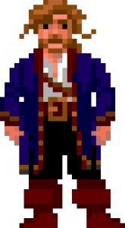

His clothes are similar to those pictured above, though the jacket is a dark burgundy and his hair is a dark brown.

### Background

* His backstory is unknown to the player until very late in the story
* He was a merchant sailor with a family in Florence. His family was killed by his debtors and he was forced into the start of his pirate career
* He decided that the world doesn’t mean anything to him long ago, and has been a cold killer ever since

### Motivation

* Piracy is the only thing he has left
* Wants to cause destruction all around the world
* Hates the world

### Relationships

* Jacob hates even the thought of Red Jacket
* Hero’s mother was killed by his crew
* Marco hates what he did to the Hero
* Barkeeps and merchants occasionally talk of him

## **First Mate (Jacob)**

### Overview

Jacob is the character that is the driving force of the Hero. Through his jealousy and disgust with the pirate crew, he constantly keeps the goal of redemption in mind.

### Description

* Constantly reminds Hero of the journey to confront the pirate villain

### Looks

* Well built, adventurous individual



### Background

* Grew up in a small port town outside Valletta, Malta with the Hero
* Best friends with the Hero since they were babies
* Loves to explore
* Expert fisherman

### Motivation

* One day, the small port town outside Valletta was pillaged and burned to the ground by Captain Red Jacket’s crew. Jacob is driven by his emotions to one day destroy the same pirate crew that destroyed his town and the people in it.

### Relationships

* Best friend to the Hero
* Hates the Captain Red Jacket

## **Mother/Father**

Overview

The parents of our Hero are a huge influence in their life. The Hero values and respects their parents. The father is a major role model for the Hero, and provides a driving force for the Hero to keep moving forward.

### Description

* Parental figures dressed in age appropriate clothing
* Father is missing, assumed to be deceased
* Motivation for the player to take revenge upon the pirates

### Looks

* Mother has a long dress with a black apron
* Father is/was a sailor - large build, stern looking face
* Father can be seen in flashbacks

### Background

The father and mother are an important influence in the Hero’s life. The Hero grew up idolizing their parents. The father is a sailor, and passed his love of the sea and adventure on to the Hero. One day the father sets out to explore the surrounding islands, but a storm hits, and the father gets lost at sea. The ship comes back, thanks to the help of the father’s first mate. The first mate and the rest of the crew decide to stay on and be part of the Hero’s crew, and continue to offer guidance when necessary.

### Motivation

* Parental figures
* Provide motivation for the player - they come back, and see that their mother is dead. They want to avenge their parents death
* The player is also motivated by the father - he is the Hero’s idol and biggest role model

### Relationships

* Married to each other
* Mother/Father to the Hero
* Friends of the original crew

## **Love Interest (Angelo/Angela)**

## Overview

The Love Interest is the counterpart to the Hero, the one thing keeping the Hero in the Mediterranean. They are the reason to stay, and a reason to keep coming back to the Rome. Letters arrive at different points of time from the love interest to keep reminding the Hero to come back to Rome.

### Description

* Opposite gender of the Hero
* Located at the first port you travel to - used as motivation for the tutorial mission
* Male - Angelo
* Female - Angela

### Looks

* Female - akin to Leah from Stardew Valley. Not super flashy, just warm and inviting.
* Male - same as the Female Love Interest, not very flashy, just nice looking and comforting.

### Background

* Lived in Rome all their life, met the Hero during one of their trips into Rome with their father.
* Loves living in Rome, wants to convince the Hero to stay

### Motivation

* In love with the Hero, wants to keep them in the Mediterranean and live with them in Rome.

### Relationships

* Love interest of the Hero
* Butts heads with the First Mate

## **Ghost**

### Overview

Character that shows up the first night on the Hero’s boat. The ghost looks eerily similar like the father, but this is neither confirmed nor denied. This character offers both comic relief as well as occasionally a sense of guidance.

### Description

* Not a creepy/scary figure, just appears and disappears on a whim 
* Appears on one of the first few nights on the ship
* Generally is a grumpy, snarky character

### Looks

* Face and build exactly like the father
* Grayed out, translucent

### Background

The ghost character looks suspiciously like the father, and it makes sense in the story - the father is lost at sea, and this ghost is on the father’s original boat. However, this is a conclusion that the player comes to on their own, as it is never explicitly stated.

### Motivation

The ghost character offers comic relief. He also, on the rare occasion, offers guidance. He usually has witty comebacks and snappy remarks to whatever is happening to the Hero. Most of the time, the Hero will just ignore what they say. On the very rare occasion that the Hero is at a loss on where to go or what to do next, the ghost will have some salient point to make that clears things up (can be used as reminder of gameplay mechanics).

### Relationships

* Offers comic relief to the Hero
* Occasionally offers guidance to the Hero
* Seems to like the original crew much more than any member of the crew that joins after the Hero starts their journey

## **The Kraken**

### Overview

The Kraken is a lesser character who the player will come across first in a small side mission, and then randomly throughout the travels.

### Look

* Very large, at least 150 feet tall
* Huge menacing head
* Body like a gigantic squid
* Blood Red in color

### Background

The Kraken is an ancient sea monster who is at least 2000 years old. Long ago, he made his home in a secret abyss in the Mediterranean. There he slept until he is awoken by the pirates accidentally and the player meets him first in a small mission to investigate an unsettling part of the water.

### Relationships

* Hero meets him on a quest and becomes a friendly yet neutral character
* Marco instantly becomes friends with him
* Jacob is terrified of him
* All other characters don’t really believe he’s real

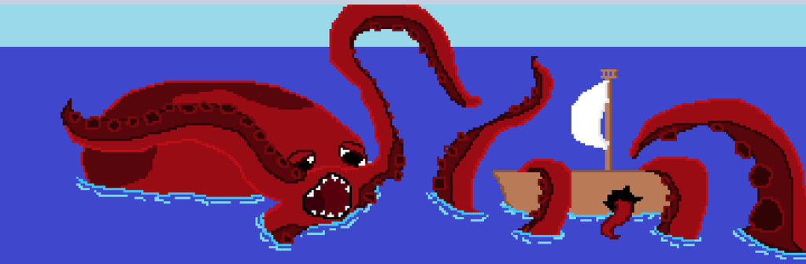

## **Barkeepers**

### Overview

Barkeepers are found in taverns in towns, selling drinks and keeping the peace. Barkeepers are firm and sometimes physically intimidating in order to stop people from causing a ruckus in their workplace.

### Description

* Barkeepers are the eyes and ears of the town, knowing some small bits and pieces of secret information in the town from people spilling their information while drinking

### Looks

* Strong Men
* Attractive Females
* Alternatively
  + Strong Women
  + Attractive Males

### Background

* Barkeepers are normally from the town that they work in

### Motivation

* Barkeepers are motivated to maintain their tavern
* Barkeepers are motivated to assist the Hero after completing a small task

### Relationships

* Helpful towards the Hero by providing missions and information

Note: The Barkeeper in Venice will be named Polo.

* Polo is Marco’s Brother
* When you travel to Venice, Marco will always be found in the Tavern talking to Polo instead of on the ship

## **Merchants (Michael)**

### Overview

Merchants are found in their shops in every town, selling various goods specific to that town. The merchants in the game are all variations of one character - Michael, the quintessential, friendly, middle aged shopkeeper. Michael’s shop has the same sign in every port.

### Description

* Workaholic - spends most of their time in their shops
* Has various other family members based in different ports
* Will already know about the Hero from letters from their brothers

### Looks

* Happy, middle-aged man with a beard and a hat
  + Different hat at every port
* Large in stature, both in height and weight

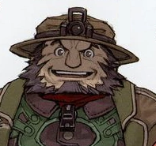

### Background

* Every merchant is a variation on Michael, but with a different hat. Michael will always talk about his brothers at other ports
* Dialogue makes the player think it might all actually be one person

### Motivation

* Make a fortune by buying and selling goods in their shop
* Make friends with travelers and stay connected with their brothers.

### Relationships

* Brother to every other merchant at other port
* Friendly to the Hero

### Variations of “Michael”

* Istanbul - Mikail
* Venice - Michel
* Rome - Carmichael
* Tangier- Mike (British)
* Tunis - Mikel
* Alexandria - Mikha’il
* Barcelona - Miguel
* Nice - Michal
* Athens - Michail
* Malta - Micah
* Havana - Miguelito

## **Shopkeepers**

### Overview

* Shopkeepers are one type of NPC that the player will meet in port
* Shopkeepers will trade with the player
  + Shopkeepers have more ordinary goods than Michael
* Shopkeepers occasionally give quests

### Description

* Provide a place to trade goods in the town
* Keeps stock of generic goods that differ from town to town

### Looks

* Shopkeepers will have an appearance consistent with the port they’re in
* Dialog will have some of the local dialect, but most dialect will be in English for the player’s convenience

### Motivation

* Shopkeepers want to make money by buying/selling goods with the player.
* Shopkeepers may also act on pride towards the port he’s in

## **Shipbuilders**

### Overview

Shipbuilders are one type of NPC that players will meet in port. Shipbuilders can be hired to upgrade the player’s ship, and occasionally give quests.

### Description

* Can repair/upgrade the Hero’s ship
* Has unique styles of ships available depending on the port

### Looks

* Shipbuilders will have an appearance consistent with the port they’re in. Shipbuilders will wear aprons and might carry tools
* Dialog will have some of the local dialect, but most dialect will be in English for the player’s convenience

### Motivation

* Shipbuilders want to make money by taking jobs from the player
* Shipbuilders also act on pride towards the port they are in and the work that they do.

## **Port Authorities**

### Overview

Port authorities are one type of NPC that players will meet in port. Port authorities give quests, and will give the player historically accurate information about the port they are in.

### Description

* Act as the main quest givers for the Hero
* Gives small tidbits of information about the area

### Looks

* Port authorities will have an appearance consistent with the port they are in
* Dialog will have some of the local dialect, but most dialect will be in English for the player’s convenience

### Background

* Usually from the port they’re in, or else became really impressed with the port

### Motivation

* Port authorities want to show off the port they’re in, which they’re proud of

## **Village Idiot**

### Overview

Another character the Hero knows will be at every location. They provide comic relief to the Hero, and usually have some antics they are getting up to. Sometimes they have quests for the Hero as well.

### Look

* Dressed up like a court jester
* Hat with bells on it, makes noise
* Usually looks pretty goofy 

### Background

* No real backstory or background, they just appear randomly throughout the cities to cause mischief

### Gameplay

* Some village idiots will have small quests that involve helping them with their tom foolery, usually involving pranking another citizen

### Motivation

* Village idiots want to cause trouble in their cities, but are usually harmless.
* They add a bit of comic relief to the game

## **Sailors/Crew**

### Overview

Sailors are found around port towns, or as a result of quest lines. All sailors are able to join the Hero’s crew, if the Hero decides to recruit them. All sailors are randomly generated, with traits selected from port-specific lists (skin color, dress, hair color, etc).

### Description

* Rugged sailor-type person, male or female
* Randomized name (port and gender specific)

### Looks

* Port-specific dress
* Randomized features

### Background

* Very vague, just know them as a sailor looking to see the world
* Some sailors start with the first ship the Hero has. These sailors were on the Hero’s father’s ship, and decided to stay and travel with the Hero.

### Motivation

* Fame and Glory

### Relationships

* Friendly to the Hero

## **Pirate Crew**

### Overview

Pirates can be found randomly in ports causing mischief or trying to fit in with the crowd. Most of the time they are peaceful, but on the rare occasion there might be a mission to stop a group of pirates from creating havoc in a town or city.

### Description

* Pirates are placed throughout the game with intents to both hinder and fight the Hero in order to stop him from continuing onward

### Looks

* Pirates look burly and are very rugged, usually unshaved; some actually just lack the ability to grow beards
* They rarely care about the Hero’s desire to talk to them, just straight sassy

### Background

* Pirates are combative in that they can be fought at sea in ship battles, but at ports, they are just normal NPC’s who you can talk to

### Motivation

* Pirates are motivated by their desire to make their crew the best it can possibly be, whether it's by pillaging for loot or defeating smaller crews

### Relationships

* Pirates associated with Captain Red Jacket
  + Provokes the Hero
  + Assists Captain Red Jacket as members of his crew
* Most pirates are just part of their own crew, separate from Captain Red Jacket
  + Provokes the Hero

## **Town Guides**

### Overview

At each city, there are famous monuments associated with that city. The player can go through the city to those monuments, and meet the town guide. The town guide will tell them a little bit about each of the monuments, and also often give them a unique quest to complete. Sometimes these quests take place just in the city itself, but often they require the Hero to go to other cities or to explore the sea nearby.

### Description

* Town guides are located in each city, near or around the famous monument of each city
* They’re relatively calm in demeanor, and they get excited about the city and monument

### Looks

* The town guides look like other NPC’s who you can talk to, but they are always standing around the monuments so the player knows who to look for
* They look pretty nerdy and scholarly

### Background

* Town guides are NPC’s that you can talk to, and they give out quests

### Motivation

* Town guides are motivated by their love of the history of the city they are in
* Their quests involve getting items from around the city, or from other cities so that the guides can learn more about the cities around them

### Relationships

* Town guides give the Hero an opportunity or reason to explore the city and surrounding cities

## **Marco**

### Overview

Marco is the mentor figure in the game, and is the person who brings the player their first ship and teaches them to sail.

### Description

* Happy, friendly, adventurous, middle aged man
* Loves the Hero like his own
* Thrill seeker

### Background

* Was the quartermaster on the father’s ship
* Old family friend of the Hero
* Started as a tavern owner in Venice
* Came to give the Hero their father’s ship and start their adventure

### Looks

* Average height with a slim build
* Weathered appearance
* Grayish hair
* Walks faster than all other characters
* Always has at least a smile on his face

Motivation

* Loves the Hero
* Wants to help the Hero start their own adventure
* Wants vengeance for his home town
* Dreams of adventuring again like when he was young

### Relationships

* Like a second father for the Hero
* Knows Jacob well and treats him like a son
* Family friend of the Hero, and hates Captain Red Jacket for what he has done

# **Goods Appendix**

These items can be bought/sold to merchants in any port. They may also be found during your adventure.

|  |  |  |  |
| --- | --- | --- | --- |
| Item | Purpose | Rarity | Price (gold) |
| Wood | Upgrade | Common | 30 |
| Food (and Water) | Depleted While Sailing | Very Common | 1 |
| Fish | Sell/Backup Food | Common | 3 |
| Bronze | Buy/Sell/Upgrade | Common | 15 |
| Stone | Buy/Sell/Upgrade | Common | 25 |
| Iron | Buy/Sell/Upgrade | Uncommon | 50 |
| Steel | Buy/Sell/Upgrade | Rare | 100 |
| Gold (Ore) | Buy/Sell/Upgrade | Very Rare | 200 |
| Cloth | Buy/Sell/Upgrade | Common | 10 |
| Alcohol (Wine) | Buy/Sell | Common(In Italian Cities) | 30 |
| Alcohol (Rum) | Buy/Sell | Common(In Havanna and Tangier) | 20 |
| Artifacts | Collectibles/Sell | Very Rare | 200 |
| Nails | Upgrade | Uncommon | 30 |
| Cannon Balls | Combat | Rare | 75 |
| Silk | Buy/Sell | Rare (Uncommon in Alexandria) | 150 |
| Spices | Buy/Sell | Rare | 100 |
| Sugar | Buy/Sell | Rare (Common in Havana) | 150 |
| Olive Oil | Buy/Sell | Common (Rome/Athens) | 50 |

*Prices will vary based on port preferences

# **Ship Upgrades Appendix**

Shipbuilders can upgrade your ship to improve it’s stats/functionality.

* Upgrades marked as default are already installed on the ship at the start of the game.
* “Legendary” upgrades are quantitatively the best in their categories, and require the player to complete a quest in order to get them.

|  |  |  |  |
| --- | --- | --- | --- |
| Upgrade | Effects | Requirements | Cost* |
| Worn Cargo Hold | 2 rows of items | Default | NA |
| Basic Cargo Hold | 3 rows of items | Worn Cargo Hold | 5 nails  5 wood  100 gold |
| Modest Cargo Hold | 4 rows of items | Basic Cargo Hold | 10 nails  10 wood  200 gold |
| Large Cargo Hold | 5 rows of items | Modest Cargo Hold | 15 nails  15 wood  300 gold |
| Legendary Cargo Hold | Unlimited rows of items* | Large Cargo Hold  Negotiations quest | 30 nails  30 wood  500 gold |
| Worn net | 5 fish every hour in game | Default | NA |
| Basic net | 10 fish every hour in game | Worn net | 100 gold |
| Large net | 20 fish every hour in game | Basic net | 300 gold |
| Worn Hull | 100 armor (for the ship) | Default | NA |
| Basic Hull | 200 armor | Worn Hull | 5 bronze  100 gold |
| Modest Hull | 300 amor | Basic Hull | 10 iron  100 gold |
| Military Hull | 500 armor | Modest Hull | 10 steel  200 gold |
| Legendary Hull | 1000 armor  Ramming attacks do 10 more damage | Military Hull  Wanted! Quest | 10 steel  10 gold ore  200 gold |
| Riflemen | 10 damage per shot | Default | NA |
| Bronze Cannons | 25 damage per shot | Riflemen | 5 Bronze  50 gold |
| Basic Iron Cannons | 35 damage per shot | Bronze Cannons | 10 iron  100 gold |
| Strong Steel Cannons | 50 damage per shot | Basic Iron Cannons | 15 steel  200 gold |
| Legendary Cannons | 50 damage per shot, shoots 3 at a time | Strong Steel Cannons  Alchemist Escort Quest | 20 steel  20 gold ore  200 gold |
| Worn Sails | Slow | Default | NA |
| Basic Sails | Moderate speed | Worn Sails | 10 cloth  50 gold |
| Large Sails | Fast | Basic Sails | 20 cloth  200 gold |
| Legendary Sails | Really fast | Large Sails  Treasure Hunter Quest | 700 gold |
| Small Crew Quarters | Can have 5 crew members | Default | NA |
| Modest Crew Quarters | Can have 10 crew members | Small Crew Quarters | 10 nails  10 wood  100 gold |
| Large Crew Quarters | Can have 15 crew members | Modest Crew Quarters | 25 nails  25 wood  300 gold |

*The legendary cargo hold may have a finite number of item slots due to hardware restrictions, but it should be larger than any player would feasibly accumulate during a normal game.

# **Map**



# 

# 

# **Story Appendix**

**Prologue**

Our story begins long before the hero starts their journey. Off in the island city of Malta, a well respected sea captain sets off to explore the islands. He says farewell to his wife and young child. The child, Alex, looks up at their father with wonder in their eyes. Though very young, the child has always looked up to the father. It is in that moment that the child knows that they want to be just like their father, and one day set out for adventure as well. Years pass and Alex grows to adulthood, eagerly awaiting the father’s return, all the while yearning to leave the city of Malta and explore.

Misfortune befalls the sea captain though. A terrible storm hits the ship, and the captain is thrown overboard. After trying and failing to save him, the captain’s quartermaster Marco dejectedly turns the ship around. “We’ve been gone long enough,” Marco thinks, “it’s time to return home.” Upon arriving in Malta, Marco sees Alex running to the docks, looking everywhere for their father. Marco has the unfortunate task of telling the beloved captain’s only child and wife that their loved one has passed away. It’s especially hard to tell Alex, who has always looked to Marco like a beloved uncle. The captain’s wife bursts into tears, and the youngster is inconsolable.

Marco pulls Alex aside, and gently says. “Your father was always proud of you Alex. He used to regale me of stories from when you were a child, how adventurous you were, always getting into mischief with your curiosity. He loved you”

“He was my hero” Alex sobs, “I’ve always wanted to follow in his footsteps. And I will...” A brief look of determination passes over Alex’s eyes, before being replaced by confusion. “I just don’t know where to start.”

“There’s a lot of adventure waiting out there for you, my child.” Marco replies, “You just have to go out and find it.”

Alex returns to their mother and explains that they want to explore, just like their father. She looks off into the distance, and sadly responds “I knew one day this would come. You should see this.” She hands Alex a letter. “It’s from [Love interest]. They know you want to set out and explore, they’ve known that this was coming for a long time. They just ask that you come and visit them in Rome once before you leave.” Alex glances off into the distance. They now know where to start - Rome.

**Set Sail!**

Using their father’s boat, Alex is about to set off on their journey. Marco has graciously decided to stay on board as Alex’s quartermaster to show Alex the ropes of how to sail a ship and, more importantly, captain a crew. Alex’s mother stands at the dock, and tearfully waves goodbye as they set off towards Rome. Alex, Marco and the crew set off, and Alex looks back to catch one last glimpse of Malta before it’s out of sight. Out of the corner of Alex’s eye, they see a pirate ship slowly gliding towards Malta. Pirates are pretty common in this area, so Alex thinks nothing of it, and doesn’t notice the worried look in Marco’s eyes.

Throughout the journey to Rome, Marco proves to be an excellent teacher, showing Alex how to understand the sea currents, how to adjust the sails, and how to direct the crew. Marco also gives Alex 100 gold coins, explaining to Alex that he knows Alex will need it to get up and running. Upon reaching Rome, Alex docks at the port and explores the city a little in order to find Angel[o/a]’s house. After searching around, Alex eventually finds Angel[o/a]. They joyfully reunite, and Alex exclaims, “Oh how I have missed you my love!”

“I know!” Angel[o/a] exuberantly agrees. “It's been so long since I’ve seen you my dear!”

Angel[o/a] takes Alex around the city to explore a bit more. They meet shop keepers, bar keepers, a town guide, and a village idiot. Alex and Angel[o/a] also run into an eccentric shopkeeper named Carmichael. Alex does a double take when they see Carmichael, as he looks almost identical to Micah, an odds and ends shopkeeper in Malta. Alex and Angel[o/a] walk into Carmichael’s shop, upon Alex’s insistence.

“Buon giorno!” Carmichael exclaims as the couple walk into his shop. “What can I help you with today, my friends?”

“Do I know you?” Alex asks, puzzled.

“No, I don’t think so miei amici,” (My friend) Carmichael responds, “but you may know my brother? He lives in Malta, his name is Micah”

“Ah yes! Micah!” Alex exclaims, overjoyed to see a slightly familiar face. “I knew you looked familiar”

“Yes, I have many brothers. You can find our shops all over, and we’re always looking for goods to buy and sell”

“I’m sure I’ll see many of your brothers, I’m going to explore the world!” Alex replies, ignoring the dejected look on Angel[o/a]’s face.

“Ah maybe you can help me, miei amici. I want to send this letter to my brother Michel in Venice. Will you take it for me? I’ll give you 50 coins for it?”

Alex is just about to agree when Marco comes running up to the group. “Alex! Alex, my child! We need to leave! I have a bad feeling. We need to get home my [son/daughter]!” Alex knows that Uncle Marco has never been one to exaggerate, and so agrees.

Turning to Angel[o/a], they say “I guess I’m off, my love. But don’t fret, we’ll see each other again. One day, we can travel the world together.” Angel[o/a] tearfully agrees, and walks Alex to the docks. There, the couple sadly parts ways, and look back at each other as Alex, Marco and crew set sail for home. Unbeknownst to the couple, it would be a long time before they see each other again.

**Home Sweet Home**

Heart heavy after leaving Rome, Alex and the crew approach Malta. As the island nations becomes visible again, they once again see a pirate ship far off in the distance. Marco is visibly upset, muttering to himself, and Alex only catches snippets of Marco’s rant.

“Pirates…dirty rotten good for nothing…..Red Jacket” Marco hears.

“Red Jackets?” Alex thinks, “Why is the color of someone’s jacket upsetting Marco so much?” Alex dismisses Marco’s ramblings and focuses on their new found sailing skills. Malta gets closer, and Alex notices that something is off. Alex can’t hear the normal hustle and bustle of the city, and doesn’t see people walking along the port like normal. The sight of black, billowing smoke from the village square scares Alex. “What happened? This doesn’t look like my home.” Alex wonders aloud. Marco doesn’t answer, but his face turns as white as a sheet.

The ship docks, and Alex runs towards the center of the town and sees….nothing. Absolute devastation has hit the town, and nothing is left standing. Where there were once buildings is now nothing more than a pile of rubble. Fires burn, and the sky is filled with smoke. Soft dejected cries now fill the air where there was once children laughing. Alex sprints home, looking for their mother. Reaching the spot where their childhood home once stood, Alex is faced with a pile of bricks. Alex looks down and something red catches their eye. Pulling it out, they see that it’s the apron their mother used to wear. Alex crumbles to the ground and sobs. Alex’s cries are heard by Jacob, their childhood best friend.

“Who could have done this?” Alex wails.

“Pirates. The pirate crew of Red Jacket, the dirty pirate thief.” Jacob responds coldly. “I swear, I won’t rest until I find him. I’ll hunt him until I die.”

Not being able to stand the sight of his broken home any longer, Alex tears themself away, and looks at Jacob. “Come with me. Be my first mate. Together, we’ll sail the ocean, find Red Jacket, and we will make him pay.” Silently, Jacob nods. Alex looks into Jacob’s eyes and sees only the cold anger of revenge. Together the two start walking back towards the sea.

**Onward Eastward**

On the way to the docks, they two run into Marco again. Eyes red and puffy from crying, Marco somberly looks at the two, and says “I can’t stay here. It hurts too much. I’m coming with you.” Alex silently nods, and the three continue onto the ships. There, some of the crew members have stuck to the ship. After conferring with Marco, they decide to stay on with Alex, as they trust Alex as the child of the original ship captain.

From here the ship sets off to Venice to deliver Carmichael’s letter to his brother Michel. Jacob angrily points out that this won’t help them get revenge. Alex calmly explains that they don’t know where the pirates are now, and if they’re going to become experiences explorers and fighters, they’re going to need money, resources, and (most importantly) a bigger boat. Jacob huffs, but eventually agrees. At Venice, Alex and Jacob continue to explore, and find more quests. This is the real start of Alex’s adventure. Slowly, through quests, the ship becomes stronger, the resource become more powerful, Alex and the crew become better fighters, and the player comes ever closer to their goal. All the while, Jacob reminds Alex of the point of their mission, their quest for redemption, and Marco is a constant source of support and guidance.

Occasionally, upon leaving an island city, they will see Red Jackets pirate ship sailing off in the distance, but each time, Alex seems to be just a little too late. At one of the Michael brother’s shops, Alex overhears that someone heard that someone else whispered that someone else learned that someone else saw Red Jacket’s pirate ship leaving from Tangiers, and was heading to the Americas. Jacob and Alex exchange glances. This is what they’ve been waiting for. All this time they’ve spent preparing, and now they have a direction. However, Marco points out that they aren’t even close to being ready to fight Red Jacket. While their ship has grown, and with it came a younger, stronger crew, they still don’t have a big enough ship and crew to cross the Atlantic Ocean. They’ll have to stay the course if they want to be able to survive.

After continuing on and completing more quests, Alex eventually decides that it’s time to head to Tangiers. That night, Alex and Jacob are at the local tavern, and having a heated discussion on their plans to head to the Americas. A Spanish captain overhears and tells Alex and Jacob that he has been to Cuba before, and knows the best route to take. He would be happy to join the crew and help out, but for a hefty price. If Alex has enough for the Spaniard, they agree and decide to set off the next morning. If not, Alex and Jacob continue with quests around the islands to gain more money and build up the ship, then find the Spaniard again and set sail!

**Vengeance**

It is a long and difficult voyage to Cuba. There are occasionally storms and cloudy nights. Jacob becomes more and more angry, as he sense the fight with the pirates approaching. The friendly Spaniard slowly begins to understand the motivation behind the two young sailors much better, and worries about what this crew is getting themselves into. And Marco seems to look older with each passing day, as he increasingly worries about Alex, whom at this point he has basically adopted since Marco doesn’t have any children of his own. Eventually, the ship catches up with the Red Jackets pirate ship. Red Jackets ship fires off a warning shot, which Alex’s ship ignores. Alex’s ship sails up next to Red Jackets, and immediately Red Jackets crew boards Alex’s ship. But Alex’s sailors fight valiantly, some of them losing their life in the first place. The battle is intense, and it’s clear that Alex’s crew is giving Red Jacket’s a run for his money.

Meanwhile, Red Jacket board’s Alex’s ship. “Who are you, puny sailor?” he demands. “What makes you think you can take on Red Jacket, the fiercest pirate who roams the high seas?”

“Hello. My name is Alex. You murdered my family and pillaged my home in Malta. Prepare to die.” Alex responds.

“Ah Malta. Such a tiny, insignificant, little city. Nothing held my interest in Malta. In fact, I barely even remember it” Red Jacket retorts. He seems almost bored, as if Malta is an insignificant, distant memory to him.

This in turn provides all the motivation Alex needs. Now the battle begins in earnest. With a renewed strength, and anger coursing through their veins, they deliver the final, fatal blow. Red Jacket falls, hurt and clearly unable to recover. Alex, after so much pain and loss, has bested the fierce pirate.

After the victory, Alex’s crew raids Red Jacket’s ship. Afterwards, Alex is left with one question - what to do with Red Jacket? Alex has two options, kill him now, or let him live. The decision weighs on him. On one hand, Jacob says Alex should kill Red Jacket, since he’s caused Alex so much pain. On the other hand, Marco says Alex should let Red Jacket live, because being bested by such a younger opponent is just as embarrassing, and Alex would be leaving the pirate with almost nothing, but also wouldn’t have the guilt of killing someone on their conscience. Ultimately though, the decision is up to Alex, and only the player knows what Alex will decide.

**Epilogue**

After making their decision about Red Jacket’s fate, Alex, Jacob, Marco and the crew continue sailing on to Cuba, like they promised the Spaniard they would. From here, Alex feels a weight lifted off their shoulders, as they’ve done their duty and gotten revenge for their family. The world is their oyster now. They continue to explore this new world, Havana, and go can go back and forth across the Atlantic as they please. Thus ends the tale of the great ship captain Alex, who rid the world of the notorious pirate Red Jacket.